Judul Artikel Dua Bahasa
(Times New Roman, 13pt, bold, space 1, center)

Judul Artikel Dua Bahasa
(Times New Roman, 13pt, bold, italic, space 1, center)

[Author(s):] Nama Penulis Pertama¹, Nama Penulis Kedua / Afiliasi² (Times New Roman, 11pt, bold, space 1, spacing after 6, center)
[Afiliation:]: ¹Nama departemen, Kota, Negara (Times New Roman, 10pt, space 1, center)
²Nama departemen, Kota, Negara (Times New Roman, 10pt, space 1, center)
*email koresponden (Times New Roman, 10pt, space 1, center)

Abstract- (Times New Roman, 10pt, space 1, justify, 2 columns, column width 8 cm, column space 0,75cm) The abstract should be written in English, clearly and concisely, summing up the article theme and does not need to contain a detailed summary from each part. Basic guidelines for the preparation of a technical work for JGSM are presented. It must provide the reader with a self-contained summary of the paper. It should include a brief introduction to the paper, method, key findings, and conclusions. The abstract is limited to 200 words and cannot contain equations, figures, tables, or references. It should concisely state what was done, how it was done, principal results, and their significance.

Keywords: 4-7 words of keywords should be written below the abstract, singular or a compound word, for indexation (should not words that are used in your article’s title)

Abstrak- (Times New Roman, 10pt, italic, space 1, justify) Abstrak harus ditulis dalam bahasa Inggris dengan jelas dan ringkas, merangkum tema artikel tanpa perlu memuat rangkuman rinci dari setiap bagian. Pedoman dasar untuk penulisan karya teknis bagi JGSM dalam bagian ini. Abstrak harus memberikan ringkasan yang berdiri sendiri dari keseluruhan isi artikel. Abstrak sebaiknya mencakup pengantar singkat, metode yang digunakan, temuan utama, dan kesimpulan. Abstrak dibatasi maksimal 200 kata dan tidak boleh memuat persamaan, gambar, tabel, atau referensi. Abstrak harus menyatakan secara ringkas apa yang dilakukan, bagaimana dilakukan, hasil utama yang diperoleh, dan signifikansi dari hasil tersebut.

Kata Kunci: 4–7 kata kunci harus ditulis di bawah abstrak, berupa kata tunggal atau kata majemuk, untuk keperluan pengindeksan (tidak boleh menggunakan kata-kata yang sudah ada dalam judul artikel Anda)

PENDAHULUAN [INTRODUCTION]
(Subtitle: Times New Roman, 10pt, bold, space 1.15)
(Text: Times New Roman, 11pt, space 1.15)
Naskah hanya akan dipertimbangkan untuk ditinjau apabila bersifat asli, belum pernah diterbitkan, dan tidak sedang dievaluasi oleh jurnal lain. Dengan mengirimkan naskah, para penulis menyatakan bahwa seluruh kontributor yang tercantum telah meninjau dan menyetujui versi final. Setelah diterima, hak cipta artikel akan menjadi milik JGSM (Jurnal Geologi dan Sumberdaya Mineral).
Manuscripts will be considered for review only if they are original, unpublished, and not being evaluated by another journal. By submitting the manuscript, the authors acknowledge that all listed contributors have reviewed and approved the final version. Upon acceptance, the article’s copyright will be held by JGSM (Jurnal Geologi dan Sumberdaya Mineral).
Latar Belakang (Background)
(Times New Roman, 10pt, bold)
Latar belakang, Permasalahan, Tujuan Penelitian, Lokasi Daerah, dan Metodologi. (Scientific Background, Scientific Problem, Aim(s), Studied Area, and Methods). Masing-masing sub-bab apabila cukup panjang dapat berdiri menjadi bab tersendiri.
Background, Problem Statement, Research Objectives, Study Area, and Methodology (Scientific Background, Scientific Problem, Aim(s), Studied Area, and Methods). Each sub-section may be presented as a separate chapter if sufficiently extensive.

HASIL PENELITIAN [RESULT OF STUDY]
Menjelaskan hasil yang diperoleh dalam penelitian disertai ulasan atau teori yang mendukung diskusi dan pembahasan yang diuraikan.
Explain the results obtained in the study, accompanied by a review or theory that supports the discussion and analysis presented.
DISKUSI [DISCUSSION]
Diskusi terdiri dari interpretasi hasil dan analisis. Dalam diskusi harus berkorelasi dengan hasil lain yang telah diuraikan. Untuk mendapatkan diskusi yang jelas dan ringkas dan untuk memecahkan masalah penelitian, serta disertai gambar / peta / grafis / foto.
The discussion consists of the interpretation of results and analysis. It must correlate with other findings that have been presented. To achieve a clear and concise discussion and to address the research problem, it should be supported with figures, maps, graphics, or photographs.
Teks, Tabel, dan Gambar (Text, Tables, and Figures)
Bagian hasil dan diskusi harus disajikan dalam bentuk narasi yang jelas, didukung oleh tabel dan gambar jika diperlukan. Penggunaan elemen visual hanya disarankan apabila penyajian data secara grafis dapat meningkatkan pemahaman terhadap hasil penelitian. Penggunaan foto sebaiknya dibatasi, kecuali jika benar-benar membantu menjelaskan hasil secara lebih baik. Setiap tabel dan gambar harus diberi nomor secara berurutan dan wajib dirujuk di dalam teks.
The results and discussion section must be presented in a clear narrative, supported by tables and figures when necessary. The use of visual elements is recommended only when graphical presentation of data enhances the understanding of the research findings. The use of photographs should be limited, except when they genuinely help clarify the results more effectively. Each table and figure must be numbered sequentially and referenced within the text.

KESIMPULAN [CONCLUSION]
Berisi kesimpulan dari penelitian yang dilakukan. Menjelaskan kesimpulan penting dalam seluruh bagian dari artikel, dan harus terkait dengan konten abstrak. Hal ini dapat ditulis sebagai kalimat lengkap atau pointer.
Contains the conclusions of the research conducted. It presents the key findings from all parts of the article and must be consistent with the content of the abstract. This section may be written in full sentences or as bullet points.
UCAPAN TERIMAKASIH [ACKNOWLEDGEMENT]
Bagian ini menjelaskan sumber dana yang digunakan dalam penelitian serta memberikan apresiasi dan penghargaan kepada beberapa institusi, lembaga atau orang-orang yang membantu dalam pelaksanaan penelitian dan penyusunan artikel.
This section outlines the funding sources used in the research and acknowledges the institutions, organizations, or individuals who contributed to the implementation of the study and the preparation of the article.

ACUAN [REFERENCES]
Acuan penting bagi pembaca, oleh karena itu setiap kutipan harus lengkap dan benar. Apabila acuan tersedia dari dua sumber, masing-masing harus terdaftar sebagai acuan terpisah. Memberi nama semua penulis; tidak menggunakan drr. dan nomor. Semua acuan harus dikutip dalam teks dan yang mendukung isi, ditulis menggunakan gaya Harvard. Di bawah ini adalah beberapa contoh format yang benar untuk berbagai jenis referensi.
References are essential for readers; therefore, every citation must be complete and accurate. If a reference is available from two different sources, each must be listed separately. List all authors; do not use “et al.” or numbering. All references must be cited in the text and must support the content, written in Harvard style. Below are several examples of correct formats for various types of references.

Buku:
Koning, Tako, and FX Darmono. 1984. "The Geology of the Beruk Northeast Field, Central Sumatra. Oil production from pre-Tertiary basement rocks." Proceedings 13th Annual Convention Indonesian Petroleum Association. Jakarta. 10-19.
Marshak, Stephen. 2019. Essentials of Geology. New York: W. W. Norton & Company.

Book Section:
Stanley, Steven M. 2016. "Evolution and fossil record of bivalve mollusks." In Paleobiology II, edited by Peter R. Crowther and Derek E.G. Briggs, 353-359. Oxford: John Wiley & Sons.

Artikel Jurnal Ilmiah:
McKenzie, Dan Peter. 1977. "Plate tectonics and convection in the Earth’s mantle." Geophysical Journal of the Royal Astronomical Society (Royal Astronomical Society) 58 (2): 637-675.
Kerr, Andrew Charles, and John J. Mahoney. 2007. "Oceanic plateaus: structure, formation, and geodynamic significance." Elements 3 (5): 299-304.

Thesis/Disertasi:
Hutchison, Charles Stewart. 1968. The Geology and Geochemistry of the Malay Peninsula. Ph.D. Dissertation, London: University of London, 312.
Smyth, Heven M. 2005. Volcanic Stratigraphy and Petrology of East Java. Ph.D. Thesis, Perth: University of Western Australia, 280.

Artikel Prosiding:
Pubellier, Manuel, and Chris K. Morley. 2014. "The role of strike-slip faults in basin evolution: Southeast Asia case studies." Proceedings of the 38th Annual Convention Indonesian Petroleum Association. Jakarta: IPA Publishing. 1-15.

Artikel dari Web Ilmiah:
U.S. Geological Survey. 2023. Understanding Plate Boundaries: An Overview of Global Tectonics. U.S. Geological Survey. Accessed Januari 10, 2025. https://www.usgs.gov.

Peta / Laporan Geologi:
Simandjuntak, Tony Orang, and Surono. 1991. Peta Geologi Lembar Muarabungo, Sumatera, skala 1:250.000. Peta Geologi, Bandung: Pusat Penelitian dan Pengembangan Geologi, 1.

Penjelasan Tabel, Gambar dan Persamaan:
Tabel dan gambar harus ditempatkan sedekat mungkin dengan paragraf tempat keduanya pertama kali dibahas, dan tidak boleh muncul sebelum ada acuan di dalam teks. Jangan menggunakan bentuk singkat seperti “Fig.” atau “Tab.” ketika menyebutkan gambar maupun tabel. Semua elemen visual harus disiapkan dalam format digital, dengan jenis file PNG atau JPEG dan resolusi minimal 300 dpi.
Tables and figures must be placed as close as possible to the paragraph in which they are first mentioned, and they may not appear before being cited in the text. Do not use abbreviations such as “Fig.” or “Tab.” when referring to figures or tables. All visual elements must be prepared in digital format, using PNG or JPEG files with a minimum resolution of 300 dpi.

Format pelampiran gambar:
(Judul gambar: Times New Roman, 10pt, space 1, space before 6pt, space after 6pt)

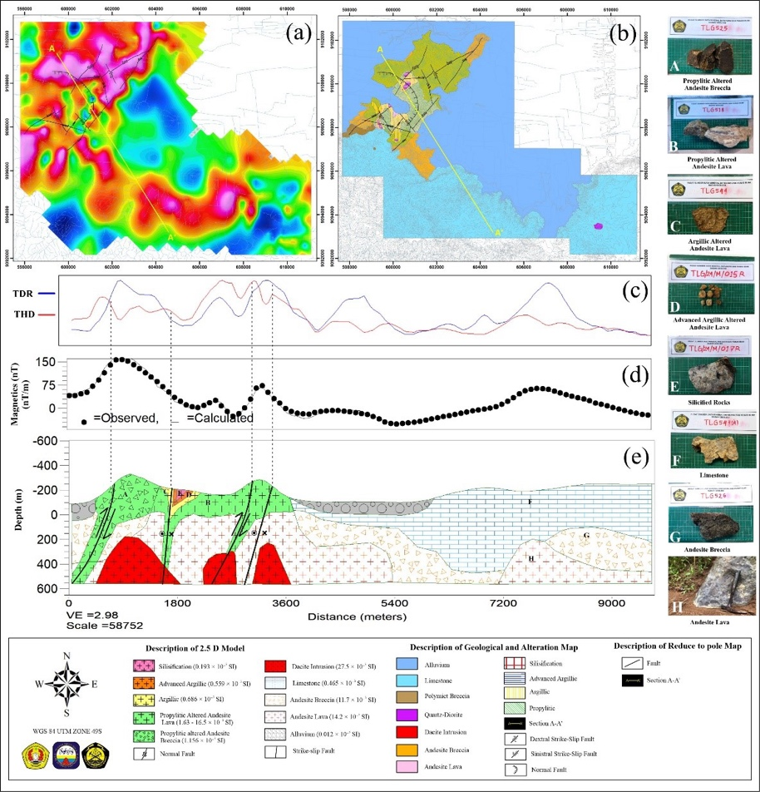
Gambar 6. The 2.5D Modeling of Section A-A', (a) The RTP map with the presence of fault structures and A-A' modeling section, (b) Geology and alteration map (Vanessa and Heditama, 2024) with A-A' modeling section, (c) Response of tilt derivative and total horizontal derivative in section A-A', (d) Response of RTP values (calculated) and observations (observed), (e) Forward subsurface modeling of section A-A
Contoh penulisan tabel:
(Title: Times New Roman, 10pt, space 1pt; Table content: Times News Roman, 11pt, space 1.15, center/align left)
Table 1. Interpretation of Magnetic Field Anomaly Values in Alteration of Epithermal Deposit Systems in the Research Area (Clark, 2014)
Interpretation of Alteration Zone | Classification | Description
Propylitic | Very Low – Very High | Magnetite-stable, weak alterated
Argillic | Low – Very High | Partially to totally magnetite-destructive
Advanced Argillic | Moderate - High | Partially to totally magnetite-destructive, med-strong oxide
Silicification | Moderate – Very High | Partially to totally magnetite-destructive, strong oxide, mineralized

Table 2. Depth Estimation of the Regional, Residual, and Noise Zones
Zone | Gradient | Depth (m)
Regional | -6.7747 | 539.387
Residual | -3.7995 | 302.508
Noise | -2.0014 | 159.347

Contoh penulisan rumus / persamaan:

The equation is as follows:
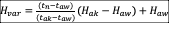 .……(1)
…….(2)
Where:
t_{n} = time at point n
t_{aw} = the time before
t_{ak} = the time after
H_{ak} = magnetic field value at the point after

