FIGURES
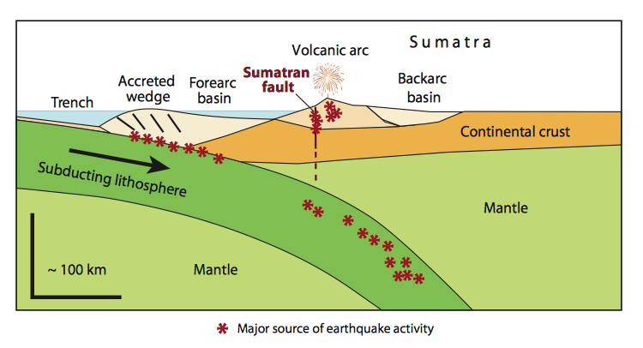
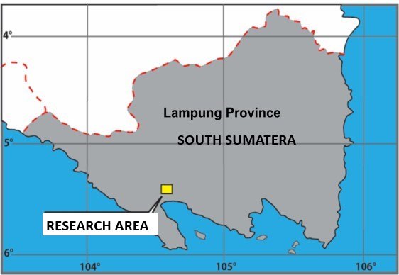
(a)
Lampung Province
Southern Part of Sumatera
(b)

Figure 1. Geological cross-section of volcanic arc zone related to the position of research area that accosiate with the development of Sumatra Island tectonics (McCaffrey,2009), where (a) is the cross-sectional line corresponding to the existence of Sumatra Fault, (b) is the research area located in the southern part of Sumatra Island.

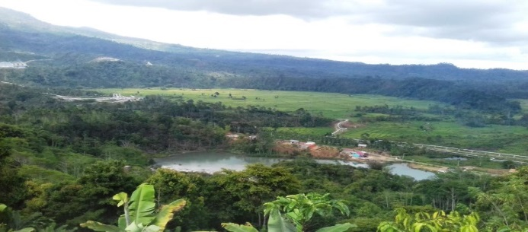
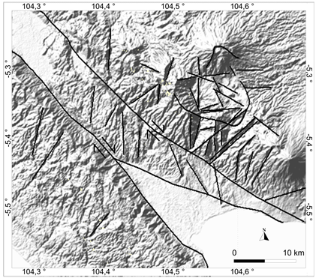
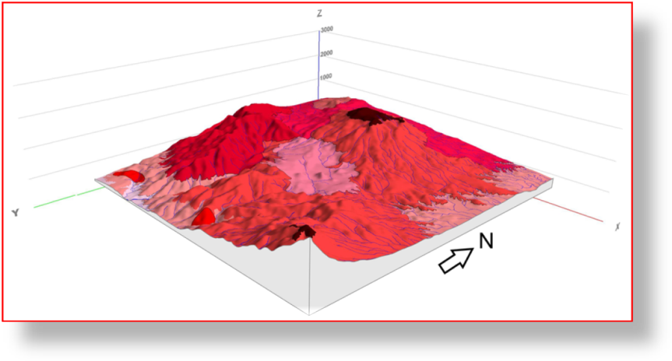
Depression area
(a)

(b)

Mt.Rendingan
Mt.Tanggamus
Mt. Sula
Sloping hills
Extremely steep slopes
Depression area
Very steep slopes
Z
Y
X
Caldera rim
Depression area
Ridge & valley lineaments
Triangular facet
(c)

Figure 2. (a). Semangko strike slip dip dextral fault system (based on DEM-SRTM image), (b) Morphology of steep hill and valley, triangular facet and depression area (based on field observation), and (c) 3 D model of morphological in the research area shows extremely steep mountain slop until plain (depression) area.

Tectonic
Geomorphology
Remote sensing
(Lineaments; SRTM-DEM and topography map)

by SRTM-DEM and topography map)
Degree of tectonic
activity
Morphotectonic
(V_{f} and S_{mf}) and rosette diagrams
Data Processing

Direction of geological structures (faults)
Field observation (validation)

Lineament of ridges and valleys, river segments, escarpment, rockslide and triangular facet.

Appearances of geothermal surface manifestation i.e. steaming ground, hot spring, mud pool, altered rock, steam heated water, solfatara and fumaroles.
Geology
Relationship between morphotectonic and the appearances of geothermal surface manifestations

segment
l surface manifestasions

Figure 3. Flow chart of research stage to determine the relationship between morphotectonic with the appearances and distribution of geothermal manifestation in the surface through remote sensing analysis and quantitative analysis (V_{f} and S_{mf}) that expressed geological structure and supported by field observation.

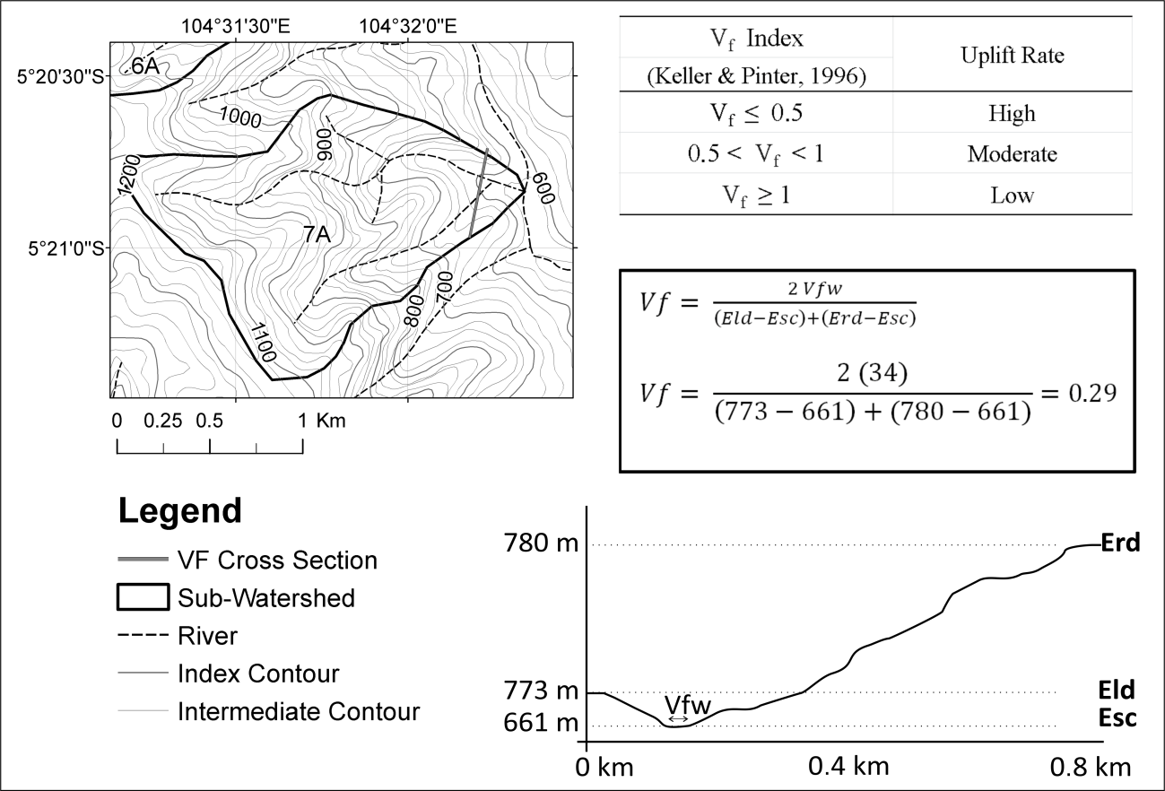
Figure 4. Illustration of Valley floor width to valley height ratio calculation (V_{f}). Here from V_{f} calculation result shows low V_{f} value is 0.29 and indicate the area has low uplift rate.

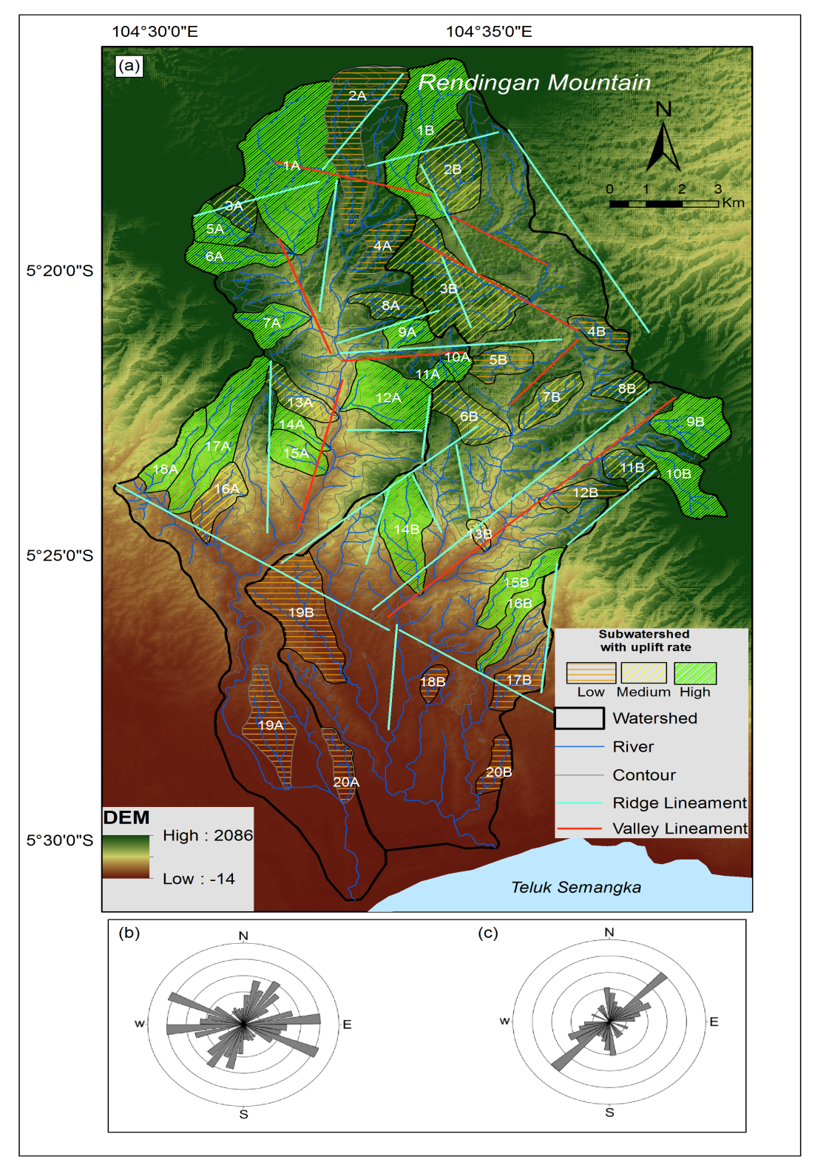
Figure 5. (a) Way Jambul and Way Belu Watersheds in the research area demonstrate the morphotectonic characteristics represented by NW-SE,NNE-SSW,NNW-SSE, and W-E structural directions that shows the uplift rates from low to high, (b) Plotting rosette diagram show the NW-SE lineament of ridges (N 294º - 336º) trending structures along the northern and western part, (c) The NE-SW valleys lineament (N 24 º- 57º) trending structure along the southeast-eastern part of this area.

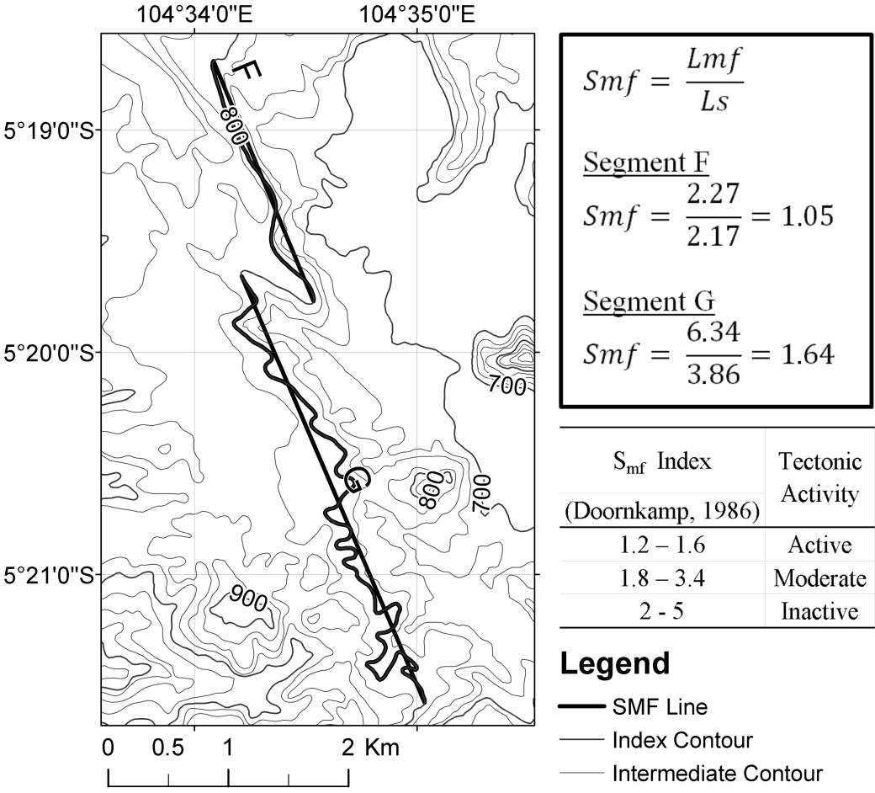

Figure 6. Illustration of two mountain front sinuosity calculation (S_{mf}) on the F and G segments of Way Belu Watershed. Here is shown segment F having an smf value in active tectonic position (1.05) as well as segment G that has an smf value 1.64 which are expressed into an active tectonic level (Doornkamp, 1986).

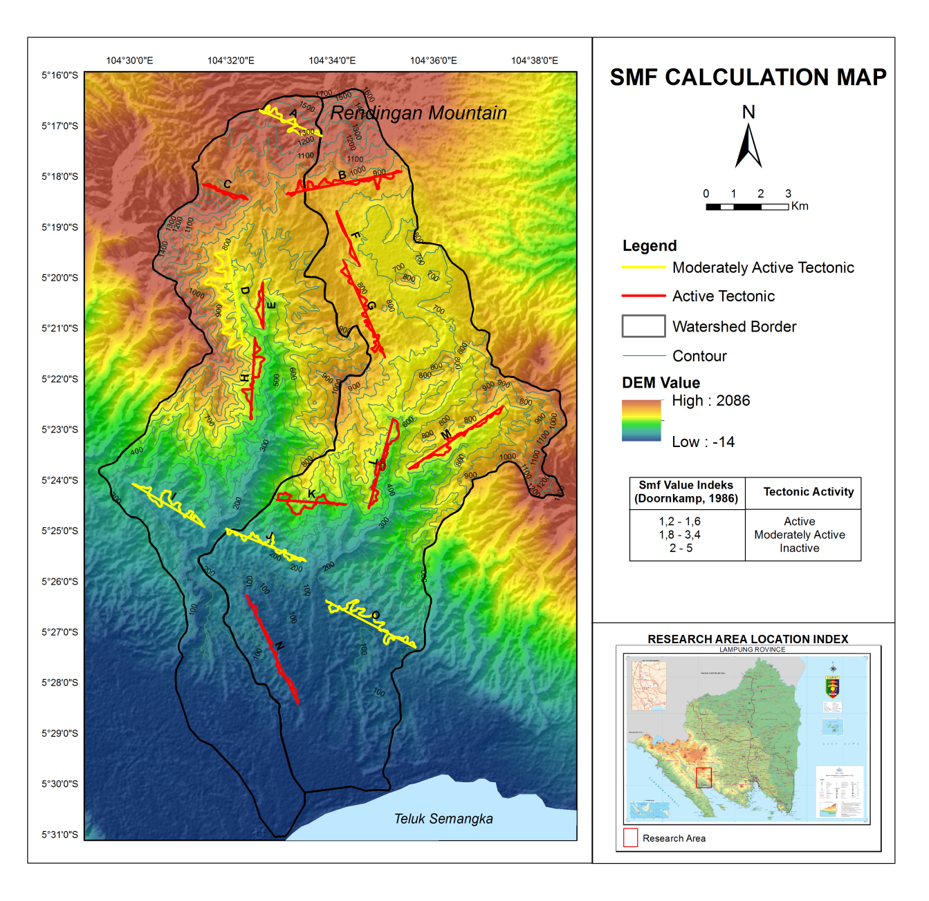
Figure 7. S_{mf} calculation map shows that from all the result of S_{mf} calculations expressed in the area have high to low tectonic activities level with the value from 1.05 to 2.09 in ranges.

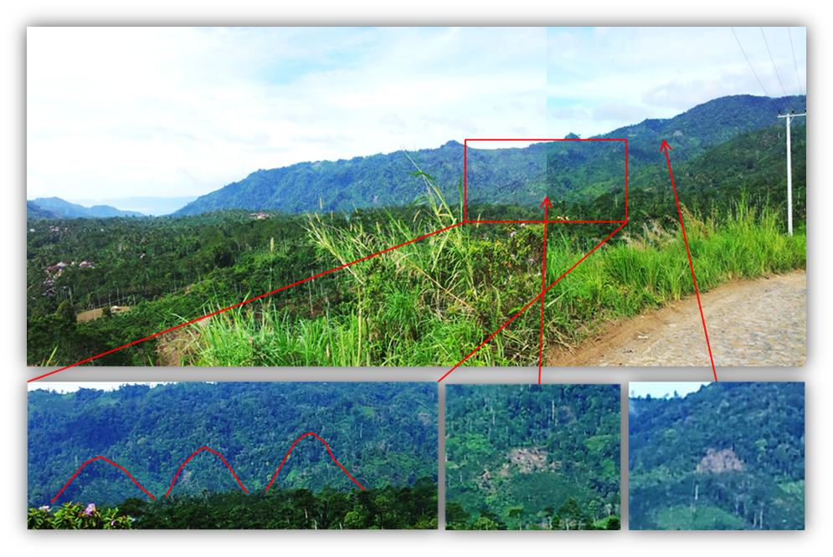
Triangular facet
Rockslide
Rockslide
Steep ridge and valley lineaments

Figure 8. Morphotectonic phenomena in the research areas such as ridge and valley lineaments, triangular facets, and landslides found to reflect the area being controlled by an active tectonic activity. This phenomenon is evidenced by the occurrence of ridge and valley that extends to have NW-SE direction in the west and middle part of the research area.

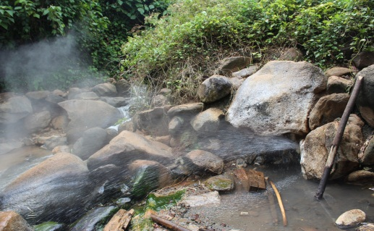
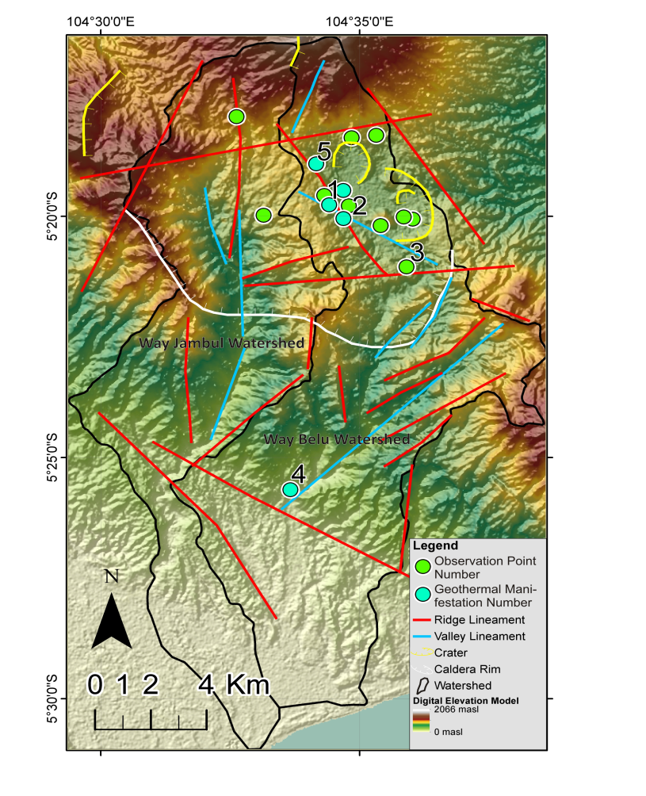
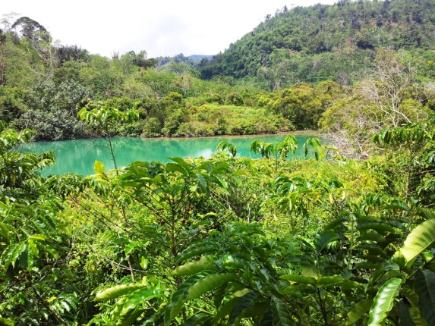
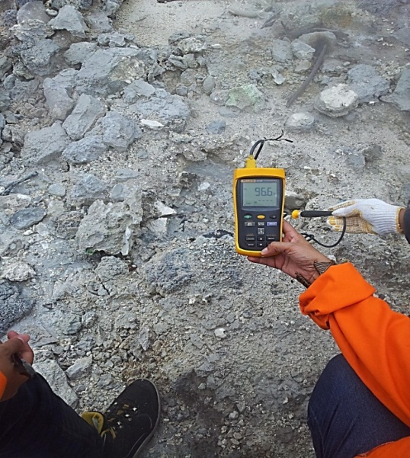
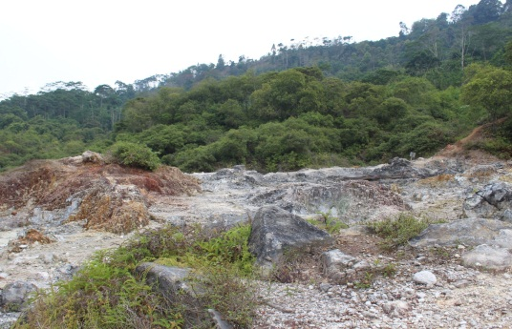
(a)

(c)

(d)

(e)

(b)

Figure 9. (a) Geology structure in the research area plays role to the appearances and distribution of the geothermal surface manifestations at the observation point number of 3,1,4, and 2 shows ; (b) Altered rock, steaming ground, fumarole, and solfatara.The steaming ground has temperature 73º-96ºC in range, (c) Steam heated water has temperature 61ºC, (d) Hot water (splashing) has temperature 91ºC, (e) Steaming ground has temperature 96.6ºC. (Imagery source; Jarvis et al., 2006).

