SCALE PREVENTION TECHNIQUE TO MINIMIZED SCALING ON
RE-INJECTION PIPES IN DIENG GEOTHERMAL FIELD,
CENTRAL JAVA PROVINCE, INDONESIA

Eko Tri Sumarnadi Agustinus^{*)}, Ildrem Syafri^{**)}, Mega Fatimah Rosana^{**)}
and Iskandar Zulkarnain^{***)}

^{*)} Study Program of Doctoral, Faculty of Geology, Padjadjaran University
^{**)} Faculty of Geology, Padjadjaran University
^{***)} Indonesian Institute of Science

ABSTRACT
Dieng geothermal field including of the volcanic geothermal system dominated of hot water. Brine water is characterized by high salinity, content of chloride (Cl⁻), amorphous silica (SiO₂), Na⁺ and K ⁺. The condition of brines water is potentially the formation of amorphous silica scale on the re-injection pipeline which is one of the obstacles in the production of electrical energy. The prevention of scale in pipes re-injection performed with non acid re-injection system. Nevertheless, the scale formed on the re-injection pipe still of relatively thick due to sludge is not optimal. Therefore, research is focused on optimizing the deposition of sludge.
The research aim is to obtain scale prevention technique on re-injection pipeline involving engineering technology. The study was conducted through laboratory experiments with factorial design method 2³ (2 levels of 3 factors). The third factor is the pH, concentration of coagulants and flocculants which acts as the independent variable. Meanwhile, the indicator is the volume of sludge deposition and turbidity of brine water which acts as the dependent variable.
The results are showed that a significant effect of pH factor, whereas the concentration of coagulant and flocculant serves to accelerate and stabilize the sludge deposition. Which are achieved optimal conditions at pH 8, the concentration of 10 ppm coagulant (PAC) and flocculants 1 ppm (Polyamide). These parameters are then used for the preparation of scaling process technology on the prevention of re-injection pipeline by adding some equipment on settling ponds. Thus, in addition to reducing environmental degradation also obtained sludge that has the potential to be used as raw material for other industries.

Keywords: engineering technology, prevention, scaling, re-injection pipe

INTRODUCTION
Unit I Dieng geothermal field, is located in Banjarnegara, Central Java Province, Indonesia (Figure 1). Geothermal systems Unit I Dieng is hot water dominated, it system is very unique compered to either geothermal system in Indonesia. The uniqueness is reflected in the form of hight content of colloidal silica in the brine water that the potential source of amorphous silica scale. The scaling problems occur either on the surface equipment such as scaling the re-injection pipelines.
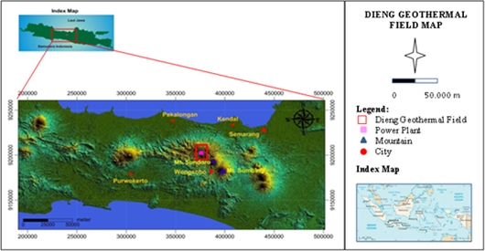
Figure1. Location map of the geothermal field Dieng

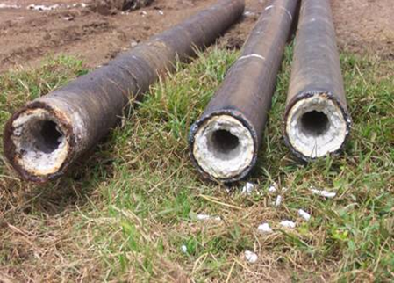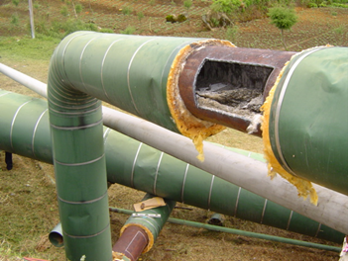Prevention of scaling in re-injection pipes is intended to prevent the formation of amorphous silica scale on the re-injection pipe (Figure 2), depending on the characteristics of the brine water in each production well. Prevention of scale in the re-injection pipe is apply using a non acid re-injection system. The process of sludge deposition is done either through open channels and settling ponds, before the brine water re-injected in to the earth. But the fact the prevention of scale through the deposition process has not lasted optimally. Although the prevention scale system has been implemented, but re-injectied pipes is already blocked by scale deposit in relatively short period (6 months).

Figure 2. Amorphous silica scale in re-injection pipes

The problem is to minimized the scaling in the re-injection pipes. The research aims to obtain new technique preventive scale process on re-injection pipes Unit I Dieng geothermal field. In order to achieve these objectives do comprehensisive study about the characteristics of brine water, scale theory, experimental optimilization of the deposition of sludge, and engineering technology. This study becomes important to be implemented, because it can provide an effort to minimize scaling on the re-injection pipes, so the electric energy production targets can be achieved.

METHODOLOGY
Framework
The formation of colloidal silica in the brine water is a result of the interaction between the water with quartz at temperatures of 200ºC. The existence of silica at the production well is always in a state of monomeric (SiO₂). The formation mechanism of amorphous silica scale begins with a silicon element which reacts with oxygen at high temperatures to form silicon dioxide (SiO₂), known as silica (Stapleton, M, 1989). Ties of some dimeric form cycle referred to as cyclic, which subsequently formed colloidal (ie: fine particles floating in the solution). If the particles will settle eventually join them as amorphous silica scale on re-injection pipe. Gunnarson and Andorson, (2003) stated that the prevention of silica scale would be more efficient if done at a high temperature geothermal fluid. Approach pH and dilution can affect the rate of silica scale (Sigfuson and Gunarsson, 2011). The statement also reinforced by the Kyoto and Uchiyama (2011), which states that the pH approach is one way to silica scale prevention.
The prevention of amorphous silica scale on re-injection pipe, can be done through two (2) approaches, namely: (1) acid approach re-injection system and (2) non acid approach re-injection system. Both approaches are illustrated in the diagram Figure 3. The diagram shows the basic principles first approach is through the reduction of pH (acid re-injection system), so that the pH of brines water becomes smaller than 4. This approach aims to maintain the brine water in a state of suspended solid, so that amorphous silica can be maintained in a floating position in the brines water. Solubility of amorphous silica (SiO₂) increases with increasing acidity. This condition will reduce the potential for the deposition of silica on the re-injection pipes. According to Gill (2011), to prevent the formation of amorphous silica scale on re-injection pipeline can be done by adding additives such as GEO 980 into brine water.

Figure 3. Diagram of acid and non acid approach re-injection system

While the second approach is the principle of precipitation sludge to produce as much as possible before the brine water is injected, so the potential for the formation of amorphous silica scale in the re-injection pipeline can be minimized. This approach is done by raising the pH to around 8 (non acid re-injection system), to consume as much as possible through the silica deposition process, so as little as possible colloidal silica particles go into the re-injection pipeline.
In order to prevent the occurrence of amorphous silica scale in pipes is done to optimize the deposition of sludge re-injection. Theoretically, the deposition mechanism is illustrated that the colloidal silica particles in the brine water that are positively charged will be attracted to a negative charged chemical. Positive ion binding is referred to as a coagulant such as Poly Aluminium Chloride (PAC) which serves to form the nucleus flock. The greater the precipitating ion valence, the faster formation of floc core. Flocculant is polyelektrolite like Polyamide compounds which serves to accelerate the larger formation of flock core. The floc-floc density becomes greater than the density of water, so that floc-floc will form a precipitate sludge settle. The rate of deposition takes place gradually through settling hindered phase, transition phase and compacting phase (Kawamura, 1991). Thus the water will be relatively clear, because of the increasing amount of sediment sludge and declining water turbidity.
Method
The research method conducted through laboratory experiments involving engineering technology. The method is illustrated in the form of a flow chart of Figure 4, shows that the optimization of the deposition of colloidal silica in brine water may occur on the role of various engineering technology variables. Stages of research conducted through the characterization of brine water, experimental optimization of the deposition of colloidal silica in brine water and preparation scaling process technology on the prevention of re-injection pipe. Experiments to optimize the deposition of colloidal silica in a brine of water carried by the method of factorial design 2³ (2 levels of 3 factors), namely: coagulant concentration (1 ppm and 20 ppm), the concentration of flocculant (0.1 ppm and 1 ppm) and pH (4 and 9) acts as the independent variable. While factorial design 1 (one) factor with 6 levels well pH, coagulants and flocculants concentration. As an indicator of the experiment are the volume of sediment sludge (mg /L) and brine water turbidity (NTU), acts as the dependent variable. The experimen results were analyzed statistically for the validation and verification of the hypothesis.

Figure 4. Flowchart of research method

RESULTS AND DISCUSSION
Characteristics of brine water in production wells Unit I Dieng is characterized by the dominance hight content of chloride (Cl) with amorphous silica (SiO₂), sodium (Na⁺) and potassium (K⁺), with lower content of calcium (Ca²⁺) and magnesium (Mg²⁺). Characteristics such brine water, tends charged positive. Therefore, it is necessary coagulan and negatively charged flocculants. Preliminary experimental results indicate that the PAC coagulant had better results than with other coagulant, that is satplok and Al₂(OH)₂ (Figure 5). Thus, further experiments to optimize the deposition of colloidal silica in brine water using a combination of PAC and Polyamide as aditive material and fairly represented by the combined sample of brine water from production wells in Unit I Dieng.
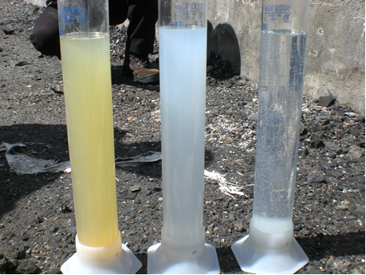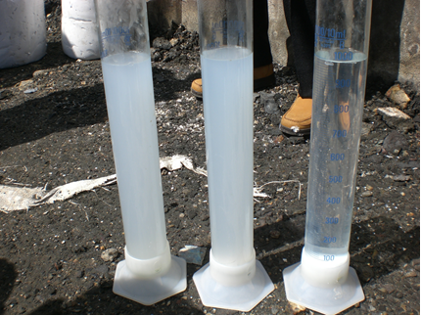
Satplok, brine water, PAC
Al2(OH)2, brine water, PAC

Figure 5. Preliminary experimental of sludge deposition

Optimization of sludge deposition
As an experimental model of a sample taken from a combination of brine water production wells Unit I Dieng. The results of the statistical analysis method ANOVA in both directions (Sudjana, 1980) on the experimental results (1) factorial design method 2³ (2 levels of 3 factors), showed that among the three factors most responsible factor pH significantly better against amount of sediment sludge and water turbidity. The condition is indicated by the value of the pH factor of significance both to the amount of sludge sediment and to brine water turbidity (sig. 0.00 < 0.05). Similarly, the results of the statistical analysis method ANOVA in one direction (Supardi, 2013) to the experimental results (2) a factor factorial design method consists of six levels, also showed that the pH is very influence significantle both the amount of sludge sediment and turbidity of brine water. Reflecting on the value of the pH factor of significance both to the amount of sludge sediment and to brine water turbidity (sig. 0.00 < 0.05).
While the experimental results (2) are presented in graphical form as shown in Figure 6, shows that the pH of the most significance influential factor. While the coagulant factor and flocculant factors showed no significant effect (Figure 7 and Figure 8). However, both of these factors are still needed to accelerate and maintain the stability of the precipitate. Optimal condition scolloidal silica deposition process in a brine water is achieved at pH 8, the concentration of 10 ppm PAC coagulant and flocculant concentration of 1 ppm Polyamide.

Figure 6. Graph of the influence of pH factor to the volume of
sludge deposits and turbidity

Figure 7. Graph of the influence of coagulant factor to the volume of
sludge deposits and turbidity

Figure 8. Graph of the influence of Flocculants factor to the amount of
sludge deposit and turbidity

Based on these parameters tested against the value of Total Suspended Solid (TSS) brine water in production wells and pond is conducted to both before and after treatment showed significant differences in TSS value. As an illustration of the difference in the value of TSS is presented in block diagram of Figure 9, indicated that the average TSS after the experiment reaches 11mg/L of about (479-1236) mg/L. TSS is very impairment significantly. Thus, the potential for the formation of amorphous silica scale on the re-injection pipe can be minimized.

Figure 9.The difference in TSS values before and after the experiment
Prevention scale technique in re-injection pipes
Technological process of the proposed scale prevention is still using a non acid re-injection system, but by modifiying the system with the principle of obtaining the sediment sludge in the clarifier optimally. The process technology is a modified version of the US Patent No.4, 900.360 as shown in the diagram of Figure 10. In principle, the process of deposition of colloidal silica in brine water stays starting from open channels and settling ponds to reduce the cost of chemicals. Optimization of sludge deposition is done by using the additional facilities, such as a combination of the tank slow mix, flash mix and clarifier. Pond as the final container can be used as equalization brine water to be processed, washer tank and filter press to dewatering.
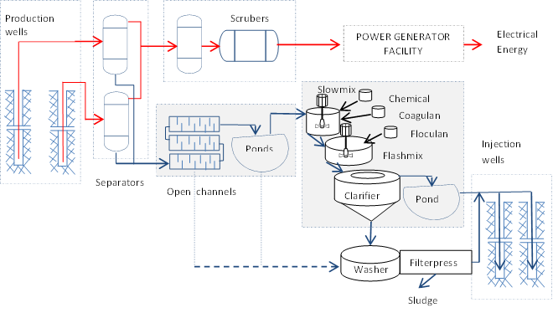

Figure 10. Flow chart of process technology scaling on the prevention of re-injection pipe (modification from US Patent No.4, 900,360)

For a discharge capacity of 100 M³/day, required construction of reinforced concrete pond with a diameter of 8.0 m with a depth of 2.0 m which can accommodate brine water for 1 day. Flash mix cylindrical reactor tank with a diameter of 80 cm with a height of 100 cm which serves for conditioning pH 8 and as a reaction koagulans (PAC) with brine water. Brine water residence time in this unit takes approximately 5 minutes. Slow mix reactor tank, a cylinder with a diameter of 130 cm with a depth of 100 cm serves as a flocculant reaction to form the floc-floc sediment sludge with a residence time of about 15 minutes. Sedimentation basin (Clarifier) ​​cylindrical conical bottom with a diameter of 500 cm and a height of 270 cm. Serves as a separation of sediment from the water with a residence time of about 60 minutes. Pond capacity treatment results shaped pond with reinforced concrete construction diameter of 5 m with a depth of 2.0 m, to be able to accommodate the water about 8 hours. Sediment washing tank diameter cylindrical sludge 6.0 m with a depth of 2.5 m to wash the sludge about 20 M³/day. All the sludge washed with water then introduced into the sludge filter press to obtain relatively clean, so it can be directly utilized for other industrial raw materials.

CONCLUSIONS
The results of the experiment showed that the pH of the most influential factors significantly both to the amount of sediment sludge and water turbidity. Engineering technology optimal parameters obtained at pH 8, the concentration of 10 ppm coagulant (PAC) and a flocculant concentration of 1 ppm (Polyamide). Prevention process scale technology on re-injection pipes is done by modifying the open channel (shaped lamella) and pond added a number of sludge deposition equipment installation. Equipment is added, among others classifier, reactor additives, washer tank and filter press sludge is placed after pond of all the brine water before it goes into re-injection pipelines. Thus, both the brine water that goes into re-injection pipeline and byproducts relatively clean sludge can be used as an industrial raw material.

ACKNOWLEDGEMENT
Our thanks goes to the Dean of the Faculty of Engineering Geology, University of Padjadjaran for the opportunity to carry out this research. We say thank you to the Directorof PT. GEODIPA ENERGY above permit the use of the brine water is given as the object of this study. We also would like to thank profusely to all those who have helped us during the study until the publication of this article.

BIBLIOGRAPHY

Gills J.S, 2011, New Inhibitors for silica and Calcium Carbonate Control in Geothermal, Procedings International Workshop on Mineral Scaling, Manila, Phillippines.
Gunnarsson I and Andersson S, 2003, Silica Scalling : The Main Obstacle in Efficients Use of Hight Temperature Geothermal Fluids, International Geothermal Converence Reykjavik,
Kawamura, S (1991), Integrated Design of Water Treatment Facilities, ISBN 0-471-61591-9, John Wiley & Sons, Inc, New York.
Kyota Y and Uchiyama N, 2011, Silica Scale Prevention Effect of Brine pH Modification at Hatchobasu Power Station, Japan, Proceedins International Workshop on Mineral Scaling, Manila, Phillippines
Stapleton, M, 1989, Scaling and Corrosion in Geothermal Operations, Power Chem Technology,775 782 4470, Mindem, Nevada 89423.
Sigfusson B and Gunnarson I, 2011, Scalling Prevention Experiments in the Hellisheidi Power Plant, Iceland, Procedings Thuety Sixth workshop on geothermal Reservoir Engineering, Stanford University, Stanford, california SGP-TR-191
Sudjana, 1980, Disain dan Analisis Eksperimen, Penerbit TARSITO, Bandung
Supardi, 2013, Aplikasi Statistika dalam Penelitian: Konsep Statitiska yang Lebih Komprehensif, ISBN 978-602-17815-5-5, Change Publication, Jakarta.
US Patent No.4, 900,360, Geothermal Treatment
Wares, Andrew Y, Leon.T , 1994, Predicting the Precipitation of Amorphous Silica from Geothermal Brines, Earth Scinces Division, Lowrence Berkely Laboratory, Berkely, CA. 94720.

