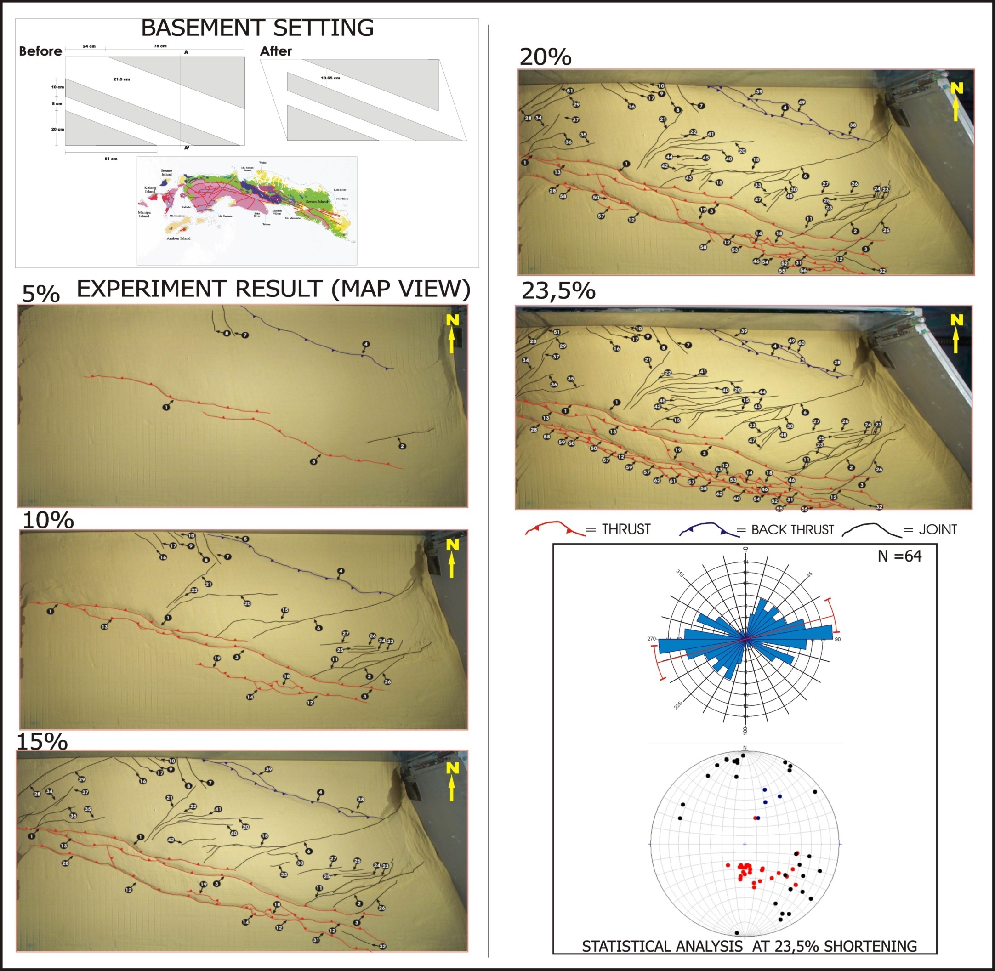

Figure 7. Example of modeling result of setting for case 3 showing sequence of fault development as a result of deformation where in this case represent by percentage of shear strain. Upper diagram show basement configuration setting and lower right corner diagram show structural distribution and orientation resulted from 23.5% of shear strain deformation.

