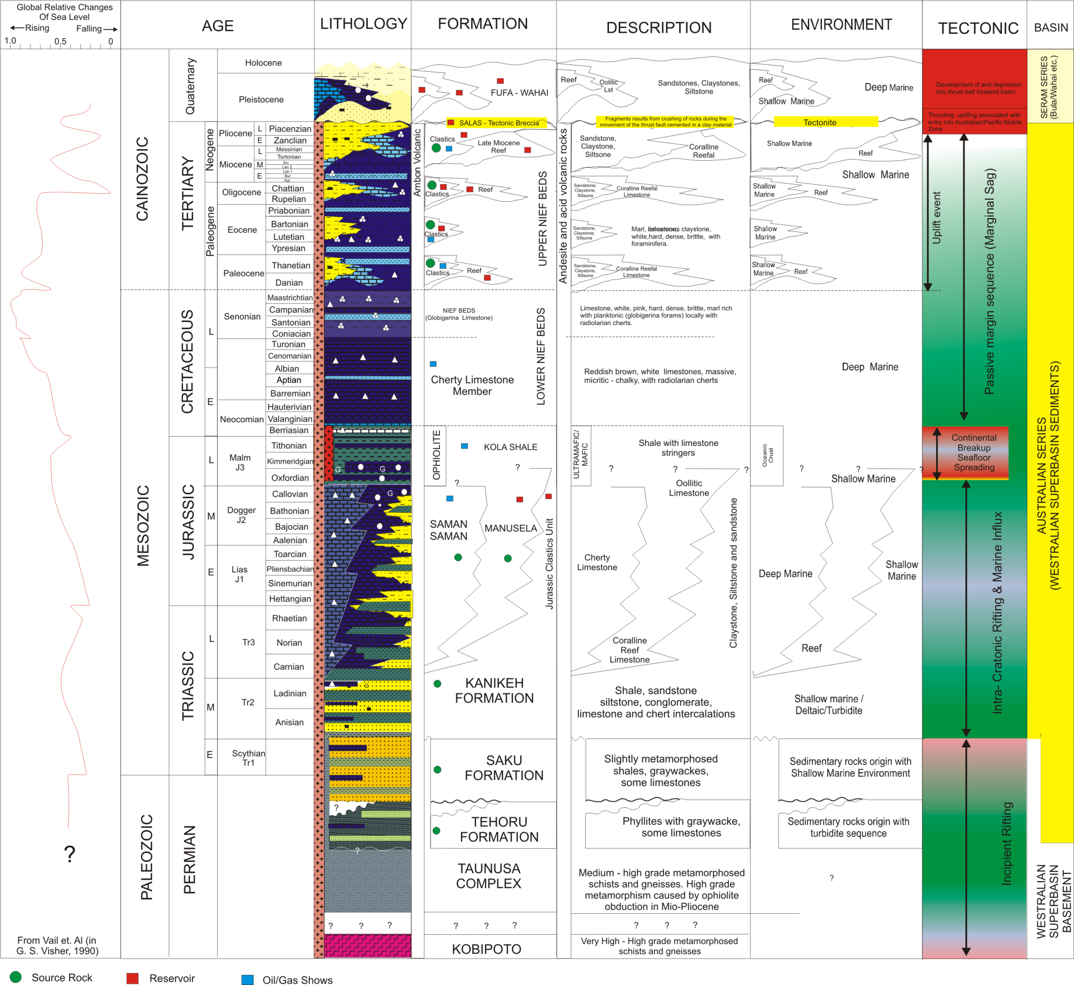

Figure 4. Regional stratigraphic column of the Seram Island showing vertical relationship of major rocks unit and formation generated based on compilation of previous worker in the island. Nilandaroe and Barraclough (2003).

