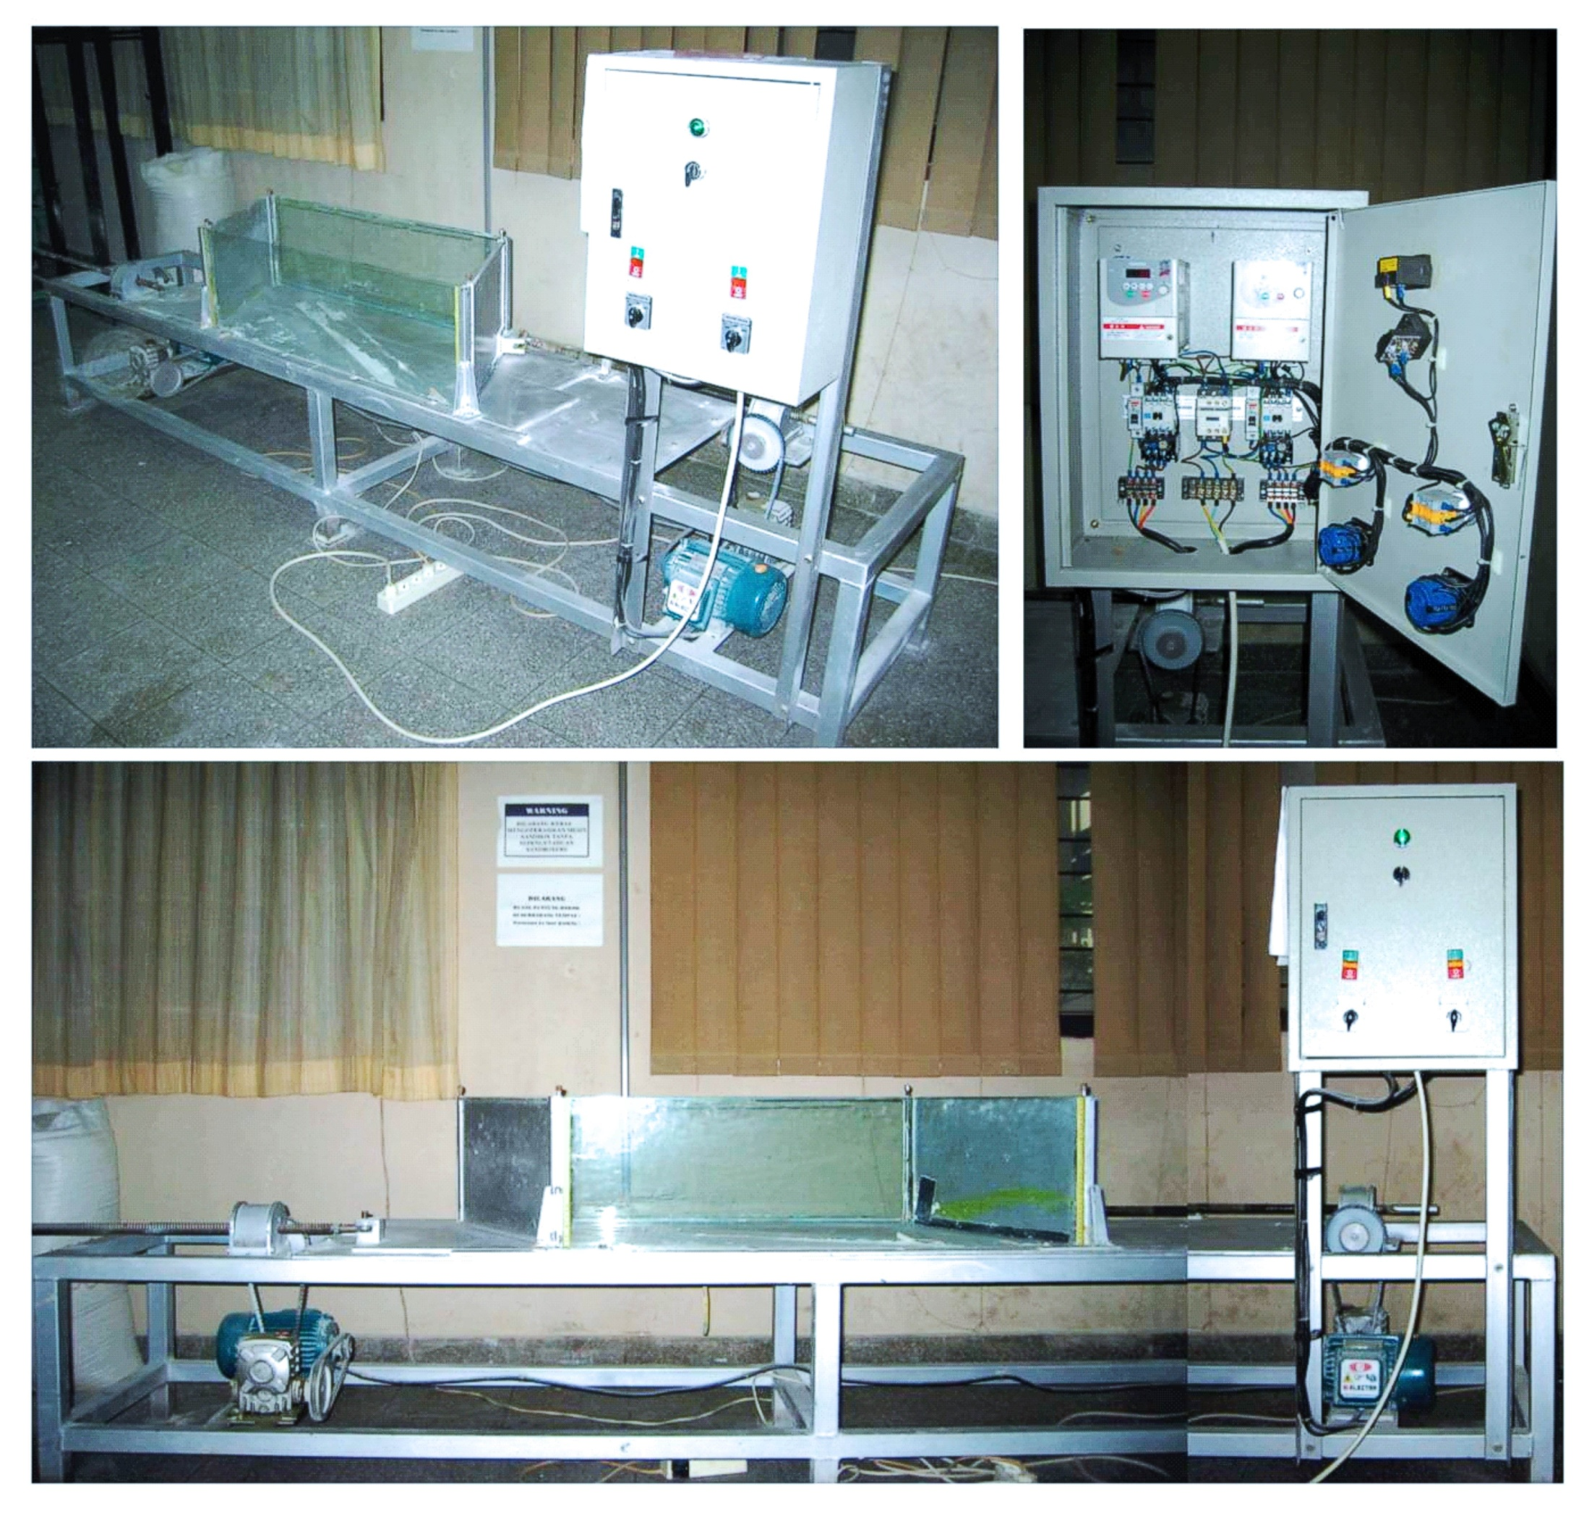

Figure 3. Sandbox apparatus shows size and sand experimental box, electronics equipment including stepper motor and control units. This apparatus specifically develops to simulate rotational strain.

