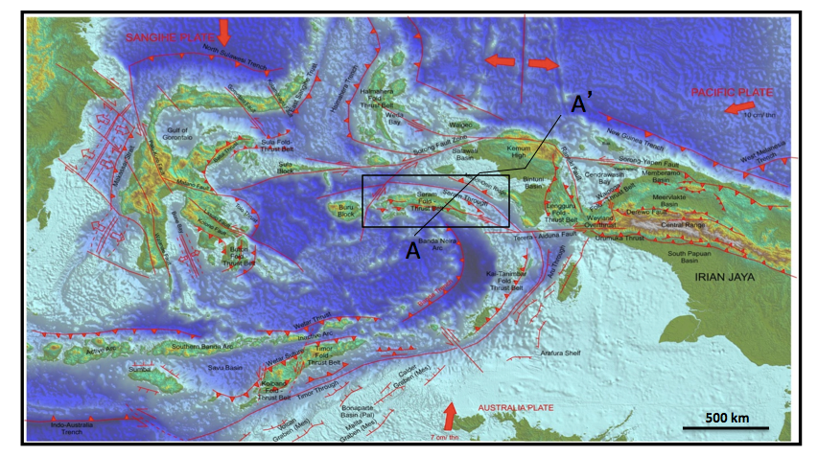

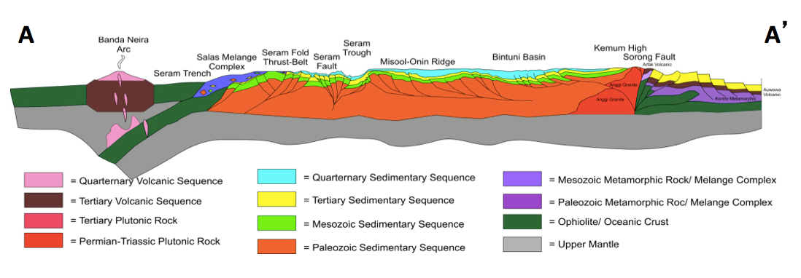

Figure 2. Tectonic setting of Eastern Indonesia region shows regional plate interactions including Seram Island structures and its surrounding boundaries. Lower diagram shows regional cross-section (NE-SW) indicating structural boundaries and relationship between Seram Island and Bird Head region (nomenclatures and boundaries is adapted from Sapiie et al., 2012).

