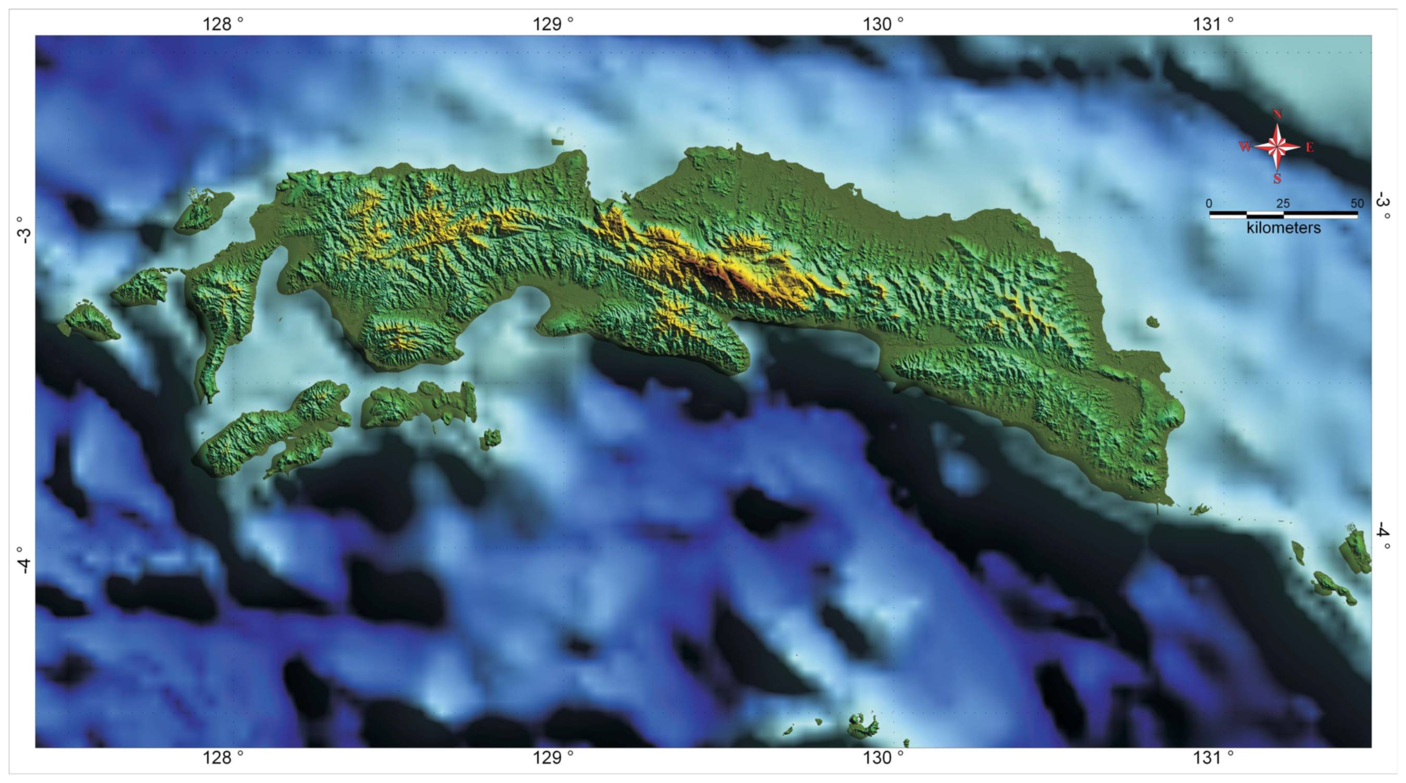

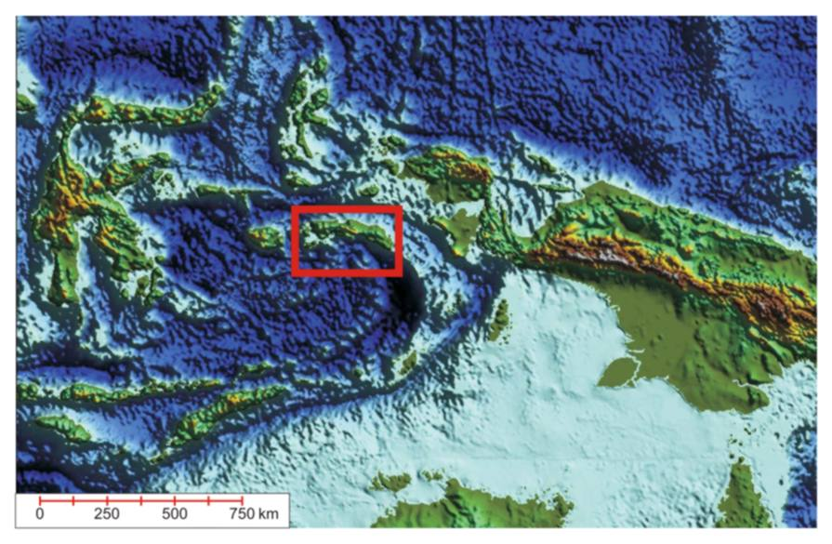

Figure 1. Location study area at Seram Island, eastern Indonesia bordered to by Banda Sea to south and Bird Head region to the north.

