Eo-Oligocene Oil Shales of the Talawi, Lubuktaruk, and Kiliranjao Areas: Are they potential source rocks?

ABSTRACT
To anticipate the increasing energy demand, additional data and information covering unconventional fossil fuels such as oil shale must be acquired to promote the usage of alternative energy sources to crude oil. The Talawi and Lubuktaruk regions situated within intra-montane Ombilin Basin, and the Kiliranjao assumed to be a small intra montane basin are occupied by Eo-Oligocene sediments of Sangkarewang and Kiliran Formations, respectively. Field activity, geochemical screening techniques, and organic petrographic analysis, supported by SEM mode, are methods used. Most of the oil shale sequence is typically of an organically rich-succession comprising predominantly well-bedded, laminated and fissile, brownish to dark grey organic-rich shale and mudstone rocks. The exinite macerals within oil shale comprise mainly Pediastrum-lamalginite with minor cutinite, resinite, liptodetrinite, sporinite, bituminite, and rare Botryococcus-telalginite. Therefore, the oil shale deposits can be described as “lamosites”. Minor vitrinite maceral is also recognized. TOC analysis on selected shale samples corresponds to a fair up to excellent category of source rock characterization. The hydrogen index (HI) for all samples shows a range of values from 207 - 864, and pyrolysis yield (PY) ranges from 2.67 to 79.72 mg HC/g rock. The kerogen is suggested to be of mixed Type II and Type I autochthonous materials such as alginite, with minor allochthonous substances. Oil samples collected appear to be positioned within more oil prone rather than gas prone. Thermal maturity of the oil shales gained from T_{max} value and production index (PI) tends to show immature to marginally/early mature stage. A consistency in the thermal maturity level results by using both T_{max} and vitrinite reflectance value is recognized. On the basis of SEM analysis, the oil shale has undergone a late eodiagenetic process. Thereby, overall, vitrinite reflectance agreeing with T_{max} rates, are also consistent with the PI (production index) values and SEM result. By evaluating all the results of geochemical and organic petrological analyses conducted on shale lithologies (shale and mudstone), it can be concluded that the oil shales in those areas have a favourable potential for generation of shale oil or gas to be included as alternative energy resources in the future.
Keywords: oil shale, alternative energy, effective source rock, lamosite, kerogen

INTRODUCTION

Background
Oil shale classified as unconventional fossil fuel resources have a high potential to provide energy and to be developed. Furthermore, as sediments, oil shale having ash content of more than 33 %, contains organic matter yielding oil when destructively distilled (Gavin, 1924). Yen and Chilingarian (1976) stated that oil shale is “composites” of tightly bound organic and inorganic components. The ratio of organics to inorganics rarely exceed ¼.
Recently, in the view point of energy resource interest, the generation potential of shale oil from oil shales, particularly as an alternative energy source, has been considered significantly as new energy resources. The oil shale has long been of interest as an indirect resource for fuel (energy) generated by a retorting process and as a possible source rock for hydrocarbon during maturation.
The continuing decline of petroleum supplies, accompanied by increasing costs of petroleum-based products may present opportunities for oil shale to supply some of energy needs. Therefore, to find other alternative energy resources of fossil fuel origin, requires a serious effort for geologists. Most such studies have considered the main source for oil and condensate. Thereby, the oil-shale deposits in Indonesia, which have not been explored intensely, may be expected to be the new fossil energy resources in the future.
As reported in several reports and publications (Suwarna et al., 2000, 2001, 2002, 2005; Kusumahbrata et al.,2002, 2003, 2004; Heryanto et al., 2002; Susanto et al., 2004; Hermiyanto et al., 2008; Wardayat et al., 2013) oil shale occurs in some parts of Sumatra, including Kiliranjao and Ombilin Basins in West Sumatra (Figure 1). Those oil shales have preliminary been studied, however their potential and quality have not been known well yet. These oil shale basins seem to superimpose the oil, gas, and coal basins, and thereby their basin setting is similar to the tectonic configuration of the clastic depositional system (Panggabean & Heryanto, 2003).

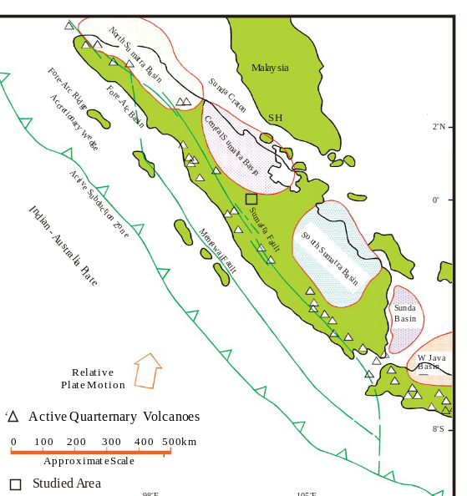
Figure 1. Locality map of the South Sumatra Basin (de Coster, 1974).

A general basic information on the presence of oil shale in Sumatra was gained from the geological maps scale 1:250.000, published by Geological Research and Development Centre, Bandung. Additional data comprising stratigraphic relationships, sedimentology, and paleontology of the Old Tertiary sediments in Sumatra were extracted from the oil and coal company geological reports.
In general, oil shale from Ombilin and Kiliranjao Basins was deposited in a lacustrine to brackish environments associated with coal depositions. The narrow rock distribution, almost parallel to the direction of Great Sumatra Fault, and bounded by faults, indicates that the oil shale deposits were accumulated within the “syn-rift” basins. Several researches, i.e. Suwarna et al. (2000 and 2001) show that some prospect areas are occupied by high oil content levels and have good prospects to be developed, such as Ombilin and Kiliranjao, West Sumatra.

Objectives
The information obtained from oil shale analyses is important for having a better understanding on the sediments and organic matter content, predominantly, relating to shale oil (hydrocarbon) potential, within the Eocene-Oligocene sediments in Ombilin and Kiliranjao Basins. This paper evaluates and discusses the potential of shale sequence exposed in Talawi, Lubuktaruk, and Kiliranjao areas, West Sumatra, on the basis of lithofacies, organic petrography, Rock-Eval pyrolysis, and SEM analyses. The understanding of studied oil shale characteristics will be useful in selecting an efficient and effective techniques for their resource potential assessment. The paper also informs "potential source rocks" those with sufficient organic content to produce hydrocarbons, whether it is oil-prone or gas-prone category, at generative temperatures, and "effective source rocks" - those potential source rocks which can be shown to have reached generative temperatures.

METHODS, ANALYTICAL PROCEDURES, AND MATERIAL

Various geologic field investigations and laboratory techniques were used, in order to achieve the aims of this study. Primary fieldwork activity includes accurate determination, observations, and measurement on sedimentology, organic matter characteristics, and detailed stratigraphy of the strata containing oil shales. Afterwards, collection of field data and samples for geochemical and organic petrographic analyses were carried out.

The laboratory techniques predominantly deal with hydrocarbon potential and organic matter type and content of the shales and mudstones forming the formation. The techniques are based on detailed analyses of petrographic and geochemical characteristics of the organic matter (DOM) and fine-grained clastics (shales and mudstones) supported by retorting mode (destructive distillation).

By measuring the quantity, quality, and state of thermal maturity of the contained organic matter, it is possible to understand the origin of hydrocarbon accumulations and potential, and to predict areas most favourable for future exploration. Furthermore, to gain effective source rock information, determination on its organic content, organic type, and thermal maturity have to be conducted.

Organic Petrology
Petrographic analysis was focused on maceral determination, especially exinite macerals and vitrinite reflectance. The samples were prepared as polished briquettes or blocks by using Australian Standard procedures (Australian Standards 2061 and 2856, 1986). The polished briquettes were prepared from crushed 1mm-size samples representing each sample, which then mounted in epoxy resin. Maceral composition and characteristics of the samples are gained from semi-quantitative examinations of polished samples. The analysis determines quantitatively the volume of organically derived, microscopically recognizable substances of organic matter, which are defined by their morphology and colour. The methods used for estimating organic carbon abundance, maceral type and composition, and vitrinite reflectance are outlined in Stach et al. (1982), Cook & Kantsler (1982), Sappal (1986), Struckmeyer & Felton (1990), Thomas (2002), and Suarez-Ruiz and Crelling (2008).
Optical method used in organic petrology analysis is reflected light method with and without fluorescence mode. The main advantage is to discriminate and locate different types of organic matter and macerals, and to measure their respective rank of evolution. The analysis provides different types of information on the thermal evolution of organic matter, particularly based on vitrinite reflectance measurements. These properties are considered to be indicators for maturation. The analysis based on 500 counts on each sample under reflected white light, was performed microscopically on polished sample sections. Ordinary white reflected light from a tungsten lamp and violet-blue light from a high-pressure mercury lamp to initiate fluorescence were used for illumination. Maceral observation was conducted on a Leitz MPV-2 photomicroscope, in GRDC and Tekmira Laboratories.
Most macerals determined are defined by the International Committee for Coal Geology (ICCP, 1963 and 1971). Hutton (1980) introduced alginite A (telalginite) and B (lamalginite) terms, based on their significant morphological differences between constituents of the alginite.
The organic petrography was accompanied by SEM technique, to provide an excellent information for revealing the type of rocks, organic and bitumen constituents, diagenesis feature and regime, and also the property of rocks, as well as to study concerning rock diagenesis (Wilson and Pittman, 1977; Pittman, 1979). In this study, however, the technique was focused on organic and bitumen constituents, to reveal oil shale characters.

Organic Geochemical Analysis
Total organic carbon (TOC), Rock-Eval pyrolysis, and also Retort Oven analyses are conducted to analyze organic geochemistry. The Rock-Eval pyrolysis, with its limitations, can be used to characterize the type of organic matter and the general nature of the hydrocarbon product (eg. oil vs. gas) which will be generated upon thermal maturation (Espitalie et al., 1977; Katz, 1983).
The quantities of organic matter in oil shale samples were determined based on the total content of organic carbon (TOC) measured by LECO analyzer and on generation potential (GP = S1+S2; free distillable hydrocarbons + generatable hydrocarbons) established by Rock-Eval pyrolysis. Hydrogen index HI (S2/TOC) was used to characterize the kerogen type. A plot of these indices on the van Krevelen diagram shows the type of organic matter present in oil shale samples. Production index S1/(S1+S2) and Tmax were used to characterize the maturity of kerogen. The analysis was carried out in LEMIGAS Laboratory.

Retort Oven Analysis
Oil shale heated in the absence of oxygen (destructive distillation) produced shale oil. This heating process is called retorting, and the equipment that is used to do the heating is known as a retort. The rate at which the oil is produced depends upon the temperature at which the shale is retorted. Most references report retorting temperatures as being about 500°C (930°F). The technique was subsequently standardized as the American Society for Testing and Materials Method D-3904-80 (1984). The analysis was conducted in LEMIGAS Laboratory.

GEOLOGY

Geological Setting
Sumatra Island is situated along the southwestern edge of the Sunda Shelf, part of the Eurasia Continental Plate, directly adjoining the Indian-Australian Oceanic Plate (Figure 1). Due to the collision between those two plates, an oblique subduction zone is produced, situated along the Sunda Trench, outside the western coast of Sumatra Island (Hamilton, 1979; Curray et al., 1979). The subduction taking place led to the presence of magmatic arc such as Barisan Mountains and dextral strike-slip fault parallel to the plate edge, that is called the Sumatra Great Fault System (Fitch, 1972). Moreover, the intra-montane basins were formed, almost parallel in direction to the fault system, that is northwest – southeast direction. Tectonically, the study areas are located at the Back-Arc Zone and Inter-Arc Zone or intra-montane area, underlain by pre-Tertiary rocks, which then is overlain by sediments and volcanics.

Talawi and Lubuktaruk Areas (Ombilin Basin)
The geologic setting and history of the Ombilin Basin has been described in several previous publications (Silitonga and Kastowo, 1975; Cameron et al., 1981; Koning, 1985). An area of approximately 25 km by 60 km, trending parallel to the Sumatera axis, is present as the exposed portion of the Ombilin Basin. The basin developed in an intra-montane setting as a result of the subduction of the Indian-Australian Plate beneath the Southeast Asian Plate, during the Late Cretaceous - Early Tertiary. It is a graben-like, pull-apart basin formed as a series of fault-bounded troughs (Koning, 1985). Predominantly, these troughs were filled with Tertiary terrestrial clastics, those are lacustrine and fluvial sediments, which overlies a complex of pre-Tertiary basement. Deposition of the Tertiary sedimentary units was tectonically controlled, and each rock unit is separated along their lower and upper contacts by a well-defined conformity with local depositional hiatus.
The principal source of the shale oil is the lacustrine – brackish sediments of Eocene - Early Oligocene Sangkarewang Formation, deposited in a subsiding basin under tropical conditions. In the deeper part of the basin, the rock unit comprises mainly calcareous shale and marl, brown to black, parallel laminated to very fissile; containing plant, fish, and bird-track fossils, as well as pyrite. Intercalations of calcareous quartz and feldspathic sandstone, graded-bedded, fining upwards, with slump structure locally. Calcareous characteristic of the rock is due to the abundance of limestone debris and bicarbonate-rich river water during the deposition of the sediments. Stratigraphically, the Sangkarewang Formation rests unconformably on the Pre-Tertiary rocks, and is conformably overlain by the Sawahlunto Coal-Measures.

Kiliranjao
The Kiliranjao Sub-basin, situated approximately 60 km to the east of the Ombilin Basin, is filled with siliciclastic-dominated sediments of the Kiliran Formation. Sedimentation of the rock unit, was tectonically controlled, and it developed in a periodically growing pre-Tertiary half-graben subbasin. The sedimentary sequence containing oil shale seams, was deposited in a lacustrine to marginal facies. Impressions of woody organic detritus (leaves, twigs, and barks) up to several centimetres in size are common to occur on bedding-plane surfaces within the siltstones.

The study area is situated probably within the westernmost part of the Central Sumatera Basin, one of the Indonesian important oil producing back-arc basins. However, it is interpreted to be an isolated small intra-montane basin, present as a nearly southeast-northwestward elongate form.
The oldest rock in the study area present as a basement of the subbasin is the Permo - Carboniferous Kuantan Group. The sub-basin is filled with Early Tertiary (Oligocene) siliciclastic-dominated sediments of Kiliran Formation and Quaternary Alluvium deposits. Sedimentation of the Tertiary sedimentary unit was tectonically controlled. The Kiliran Formation, generally, comprises a sequence of graben fill sediments, containing variegated shales and mudstones, sandstones, conglomerates, and coals. Predominantly, microlaminated to massive slightly calcareous organic-rich, brown to light grey mudstone forms the unit. Evidence of bioturbation occurs, and bottom conditions are presumed to have been anoxic. The association of frequent freshwater mollusc fossils such as Paludina sp., Brotia sp., and Thiara sp. (Aswan et al., 2009) and Bottryococcus algae contents (Suwarna et al, 2000 and 2001), indicates a lacustrine setting. Furthermore, the presence of lamalginite and telalginite sub-macerals (Figure 2),preserved assemblages of spores, and framboidal pyrite (Figure 3), suggest a freshwater with minor marine incursion environment occurred.

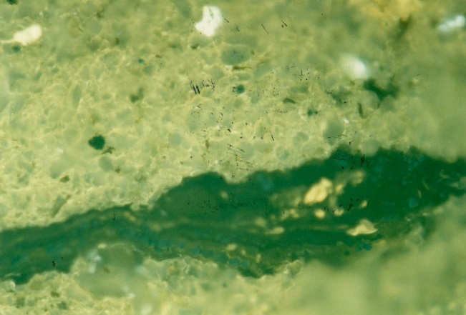

Figure 2. Photomicrograph of lamalginite, telalginite, and vitrinite in Kiliran shale (fuorescence mode).

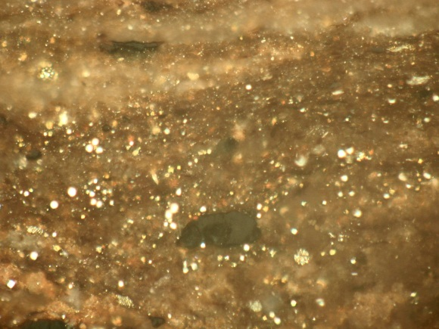
Figure 3. Photomicrograph of framboidal pyrite assemblage in Kiliran oil shale (reflected light mode).

RESULTS AND DISCUSSION

Organic Geochemical Analysis
The samples analyzed are gained from freshest outcrop and subcrop of shales and mudstones. Rock-Eval pyrolysis was performed on 18 rock samples from relatively selected representative layers of oil shales.
The TOC content of the selected samples of Sangkarewang Formation in Talawi and Lubuktaruk areas ranges from 1.10 to 8.12 % (Table 1) with averaged 3.18 %. The highest TOC content occurs in spongy mudstone (8.12 %) located in Lubuktaruk (NS 12B), followed by flaky mudstone of NS.11C (4.73 %) occurring in Sipang River. On the other hand, the lowest TOC content (1.10 %) occurs on shaly mudstone of HR.0 I E situated in Setangkai area.
The recent analyses indicate that, based on Rad classification (1984), the Sangkarewang shales and mudstones of Talawi (NS.08A, 10A, 11C, and ES.07A)and Lubuktaruk (NS.12B) areas have excellent hydrocarbon potential (Figure 4) with TOC values varies from 4.05 % to 8.12 % (mainly more than 4.0 %), pyrolysis yields (PY) between 26.62 and 67.72 mg HC/g rock (mainly more than 20.0 mg HC/g rock), T_{max} of 440° - 447° C, and hydrogen indices (HI) in 595 - 829 range. The oil shales can be categorised as oil-prone source-rock (Figure 4), while the kerogen is mainly included into Type I (Figure 5).
The good potential category is characterized by TOC value between 1.0 - 2.0 %, and pyrolysis yields (PY) varying from 6 - 20 mg HC/g rock. This category is represented by siltstone sample SB.08B (TOC of 2.45 %, PY of 16.69 mg HC/g rock), mudstone of NS.19A (TOC values 2.23 %, PY of 15.97 mg HC/g rock), DS.07A (TOC of 2.03 % and PY 6.85 mg HC/g rock) and mudstone of NS.07A (TOC value 1.61 %, PY of 7.91 mg HC/g rock), having T_{max} from 438° to 441°C, and HI (hydrogen indices) between 335 - 707 range. Therefore, those oil shales are situated in oil-prone level (Figure 4), and their kerogen is included into Types I and II (Figure 5). Moreover, their PI dominated by 0.01 values, tends to indicate a thermally immature level. However, on the basis of T_{max} and other PI values, the samples tend to indicate an early mature stage.
The rest comprising four samples is included into fair potential level (Figure 4). Two samples show TOC content of 1.10 %, and PY of 2.31 mg HC/g rock (HR.01E), and TOC of 1.63 % and PY 3.51 mg HC/g rock (NS. 01 B) both occur in Talawi area. Two others with NS. 12A (TOC of 1.22 %, and PY 2.67 mg HC/g rock) and NS.12E₁₀ (TOC 1.34 %; PY 3.56 mg HC/g rock) were collected from Lubuktaruk (Bt. Porogadang). T_{max} of the four-samples ranges from 443° to 453°C. Moreover, their hydrogen indices (HI) are in 198 - 249 range. The samples mainly belong to an oil-prone area (Figure 4), and their kerogen belong to Type II (Figure 5).

Table 1. Rock-Eval Pyrolysis Data of the Sangkarewang and Sawahlunto(Talawi and Lubuktaruk areas) and Kiliran Formations (Suwarna et al., 2000 and 2001)
No | Location | Sample Code | Lithology | TOC (%) | S1 | S2 | PY | PI | T_{max} (°C) | HI
 |  |  |  |  | kg/t |  |  | PI | T_{max} (°C) | HI
1 | Talawi Area | HR. 01 E | Mdst., shaly | 1.10 | 0.13 | 2.18 | 2.31 | 0.06 | 453 | 198
2 |  | NS. 01 B | Mdst., dk.gy-blk. | 1.63 | 0.22 | 3.29 | 3.51 | 0.06 | 446 | 202
3 |  | NS. 07 A | Mdst., brn.-dk.g | 1.61 | 0.07 | 7.84 | 7.91 | 0.01 | 438 | 487
4 |  | NS. 08 A | Mdst., dk.gy. | 4.41 | 0.38 | 26.24 | 26.62 | 0.01 | 440 | 595
5 |  | NS. 10 A | Mdst., dk.gy. | 4.05 | 0.68 | 26.44 | 27.12 | 0.03 | 447 | 653
6 |  | NS. 11 C | Siltstone, shaly | 4.73 | 0.82 | 35.15 | 35.97 | 0.03 | 440 | 743
7 |  | NS 19 A | Mdst., calc., gy. | 2.23 | 0.21 | 15.76 | 15.97 | 0.01 | 441 | 707
8 |  | ES. 07 A | Mudstone | 4.51 | 0.42 | 34.42 | 34.84 | 0.01 | 446 | 763
9 |  | SB. 08 B | Siltstone dk.gy | 2.45 | 0.11 | 16.68 | 16.79 | 0.01 | 441 | 681
10 |  | DS. 07 A | Mdst, dk.gy. | 2.03 | 0.04 | 6.81 | 6.85 | 0.01 | 439 | 335
11 |  | ES. 01 A | Mdst., dk.gy. | 1.03 | 0.06 | 2.12 | 2.18 | 0.03 | 438 | 206
12 | Lubuktaruk Area | NS. 12 A | Shale, lt.gy. | 1.22 | 0.15 | 2.52 | 2.67 | 0.06 | 439 | 207
13 |  | NS. 12 B | Mdst., spongy | 8.12 | 0.44 | 67.28 | 67.72 | 0.01 | 441 | 829
14 |  | NS 12 E 10 | Mdst., spongy | 1.34 | 0.23 | 3.33 | 3.56 | 0.06 | 443 | 249
15 | Kiliranjao Area | NS. 13 C | Mdst,. Spongy | 7.23 | 0.65 | 62.5 | 63.15 | 0.01 | 432 | 864
16 |  | NS. 13 E | Mdst., spongy | 9.03 | 1.68 | 78.04 | 79.72 | 0.03 | 432 | 864
17 |  | NS. 14 G | Mdst. | 5.94 | 0.37 | 30.63 | 31.00 | 0.01 | 431 | 516
18 |  | NS. 15 A | Siltstone | 3.00 | 0.14 | 14.52 | 14.66 | 0.01 | 432 | 484
Explanation:
TOC : Total Organic Carbon S3 : Organic carbon dioxides T_{max} : maximum temperature (oC) at top of S2 peak
S1 : Amount of free HC PY : Amount of total HC = S1+S2 HI : hydrogen index (S2/TOC) X 100
S2 : Amount of HC released from kerogen PI : production index = S1/S1+S2

The Sawahlunto Formation is represented by one sample analyzed. Sample ES.0lA showing TOC value of 1.03 % with PY of 2.13 mg HC/g rock is included into oil-prone potential (Figure 4). Its T_{max} is 438°C, with HI of 206 range. This sample falls under Type II kerogen (Figure 5).
Retort-Oven analysis indicates that the oilcontent of the analyzed samples predominantly varies from 3.0 to 97.0 l/t with averages 25.8 l/t (Table 2). The highest oilcontent occurs in sample NS.11A (97.0 1/t), whereas, the lowest oilcontent (NS 10G: 3.0 1/t); both occur in Sipang River of Talawi area. Sixteen of twenty four samples representingthe Sangkarewang Formation exhibit good to excellent level of hydrocarbon potential (oil content > 18.00 1/t). This condition is dominated by thirteen samples, that have average oil content of 37.35 1/t.

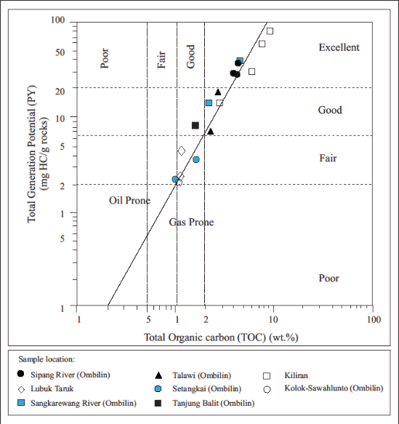
Figure 4. Diagram of TOC versus Pyrolysis Yields (PY) showing the richness and hydrocarbon potential of the Sangkarewang (Talawi including Sipang, Sangkarewang River, Setangkai, and Tanjungbalit; and Lubuktaruk areas) and Kiliran oil shales.

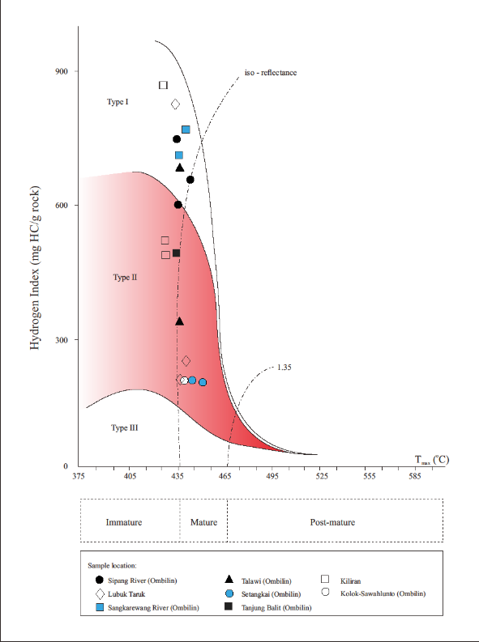
Figure 5. Hydrogen Index (HI) versus T_{max} diagram, showing kerogen type of oil shale of the Sangkarewang (Talawi, including Sipang, Sangkarewang River, Setangkai, and Tanjungbalit; and Lubuktaruk areas) and Kiliran Formation.

Furthermore, in the Kiliran Formation of Kiliranjao area, Rock-Eval pyrolysis (Table 1) and Retort-Oven analysis (Table 2) reveal that the four selected representative oil shale and fine clastic samples show characteristics as described follows. The TOC values range between 3.00 - 9.03 % , pyrolysis yields (PY) between 14.66 - 79.72 mg HC/g rock, T_{max} varies from 431° - 432° C, and hydrogen index (HI) of 484 - 864 range. Based on this data, thereby, the oil shale of Kiliran Formation is classified as an excellent potential level, included into Type I and II kerogen (Figure 5), and is dominated by oil-prone potential level (Figure 4). Thermal maturity of the samples falls onto an immature stage (Figure 5).
Thermal maturity of the rock samples are random, but it is consistent, that the rocks are included into an immature level with minor early mature (Figure 5). This condition is supported by the T_{max}< 440ºC, and the dominant hydrocarbon potential index (PI) = ∼ 0.02 (Table 1).
On the basis of Retort-Oven analysis, the oilcontent of the samples analyzed in Kiliran ranges between 22.0 and 78.0 l/t.The highest oilcontent showing excellent level of oil potential occurs in sample NS.13B, whereastwo samples (NS 14i and 15E0 have a similar lowest oilcontent.

Table 2. Retort-Oven Analysis Data of the Sangkarewang, Kiliran, and Sawahlunto
No. | Sample Code | Location | Oil Content (l/t) | Water Content (l/t)
1 | NS. 01 B | Talawi Area | 8.0 | 104.0
2 | NS. 02 B |  | 5.0 | 62.0
3 | NS. 04 D |  | 5.0 | 50.0
4 | HR. 01 E |  | 10.0 | 70.0
5 | HR. 03 A |  | 10.0 | 78.0
6 | NS. 07 A |  | 18.0 | 172.0
7 | NS. 08 A |  | 41.0 | 96.0
8 | NS. 08 D |  | 36.0 | 132.0
9 | NS. 08 G |  | 61.0 | 92.0
10 | NS. 08 J |  | 28.0 | 72.0
11 | NS. 08 L |  | 42.0 | 42.0
12 | NS. 10 A |  | 18.0 | 20.0
13 | NS. 10 D |  | 41.0 | 60.0
14 | NS. 10 G |  | 3.0 | 68.0
15 | NS. 11 A |  | 97.0 | 44.0
16 | NS. 11 E |  | 36.0 | 92.0
17 | NS. 11 -I |  | 44.0 | 62.0
18 | ES. 06 C |  | 18.0 | 72.0
19 | ES. 06 D |  | 22.0 | 44.0
20 | ES. 07 A |  | 36.0 | 100.0
21 | NS. 18 A |  | 13.0 | 118.0
22 | NS. 19 A |  | 20.0 | 98.0
23 | NS. 05 A |  | 18.0 | 200.0
24 | DS. 34 A |  | 6.4 | 44.0
25 | NS. 12 A | Lubuktaruk Area | 10.0 | 96.0
26 | NS. 12 E 10 |  | 5.0 | 70.0
27 | NS. 13 C | Kiliranjao Area | 50.0 | 92.0
28 | NS. 13 E |  | 78.0 | 232.0
29 | NS. 14 A |  | 24.0 | 192.0
30 | NS. 14G |  | 28.0 | 396.0
31 | NS. I4 I |  | 22.0 | 162.0
32 | NS. 15 A |  | 24.0 | 28.0
33 | NS. 15 E |  | 22.0 | 38.0

Petrographic Analysis
Organic petrology result presented in Table 3 shows the maceral composition of DOM and its mineral matter content of both the Sangkarewangand Kiliran Formations, and also Sawahlunto Formation.
In Talawi and Lubuktaruk areas, petrographically, the maceral composition of Sangkarewang Formation determined on twenty four selected samples (Table 3) is dominated by exinite group (0.1 - 55 %) comprising lamalginite of 0.1 - 55 %, with minor Botryococcus-telalginite (0.1 %), cutinite (1.0 - 2.9%), resinite (0.2%),

Table 3. Maceral and Mineral Matter Composition and Vitrinite Reflectance of the Sangkarewang and Kiliran Oil Shale (Suwarna et al., 2000 and 2001)
No. | Sample Code | Lithology | Area/  Basin |  |  | E  (%) |  |  |  |  | V  (%) | Rv  (%) | Py  (%) | Others  (%)
 |  |  |  | Lam | Tel | Cut | Sp | Lpt | Res | Bitu
1. | HR.03B | Shaly Coal | Ombilin | 1.0 | - | - | - | - | - | - | 42.0 | 0.22 | 0.3 | 56.7
2. | HR.01E | Siltstone |  | 0.1 | - | - | - | - | - | - | 0.1 | 0.23 | 4.0 | 95.8
3. | NS.01B | Siltstone |  | 0.1 | - | - | - | - | - | - | 0.2 | 0.27 | 0.3 | 99.4
4. | NS.03A | Siltstone |  | - | - | - | - | - | - | - | 0.3 | 0.24 | 0.2 | 99.5
5. | NS.05A | Siltstone |  | 2.0 | 0.1 | 2.9 | 0.3 | 0.2 | 0.2 | - | 1.0 | 0.28 | 1.0 | 92.3
6. | NS.05E | Sandstone |  | 0.1 | - | - | - | - | - | - | 0.2 | 0.38 | 0.1 | 99.6
7. | NS.05G | Siltstone |  | 2.5 | - | - | - | - | - | - | 1.2 | 0.37 | 0.3 | 96.0
8. | NS.05J | Claystone |  | 1.0 | - | - | - | - | - | - | 0.1 | 0.21 | 5.0 | 93.9
9. | NS.06A | Siltstone |  | 25.0 | - | - | - | - | - | - | 0.1 | 0.25 | 4.8 | 70.1
10. | NS.07A | Siltstone |  | 5.0 | - | - | - | 0.2 | - | - | 2.0 | 0.22 | 5.2 | 87.8
11. | NS.08A | Sandstone |  | - | - | - | - | 0.1 | - | - | 0.1 | 0.32 | 0.1 | 99.7
12. | NS.08G | Claystone |  | 55.0 | - | - | - | 1.0 | - | 0.1 | - | - | 6.0 | 37.9
13. | NS.08L | Claystone |  | >55.0 | - | - | - | - | - | - | 0.1 | 0.19 | 5.8 | <39.1
14. | NS.10A | Claystone |  | 43.0 | - | - | - | 2.0 | - | - | 0.1 | 0.19 | 6.6 | 48.3
15. | NS.10G | Siltstone |  | 0.6 | - | - | - | - | - | - | 1.0 | 0.24 | 1.0 | 97.4
16. | NS.11A | Siltstone |  | 19.5 | - | - | - | 0.5 | - | 0.1 | 4.0 | 0.17 | 5.2 | 70.7
17. | NS.12A | Claystone |  | 2.5 | - | - | - | 0.1 | - | - | - | - | 0.8 | 96.6
18. | NS.12B | Claystone |  | 27.5 | - | - | - | 2.5 | - | - | 0.1 | 0.22 | 5.2 | 64.3
19. | NS.12E | Shaly Coal |  | - | - | 1.0 | 1.0 | - | - | - | 42.0 | 0.36 | 15.0 | 41.0
20. | NS.18A | Siltstone |  | 1.4 | - | - | - | 0.1 | - | - | 0.3 | 0.20 | 4.8 | 93.4
21. | NS.19B | Siltstone |  | 29.9 | - | - | - | 1.0 | - | 0.1 | 0.2 | 0.19 | 4.6 | 71.2
22. | RH.02A | Siltstone |  | - | - | - | - | 0.1 | - | - | 0.2 | 0.40 | 0.8 | 98.9
23. | RH.02K | Siltstone |  | - | - | - | - | - | - | - | 0.2 | 0.37 | 0.2 | 99.6
24. | RH.02P | Siltstone |  | 0.4 | - | - | - | - | - | - | 0.2 | 0.25 | 0.3 | 99.1
25. | NS.13C | Siltstone | Kiliran | 0.3 | - | - | - | - | - | - | 4.2 | 0.25 | 0.2 | 95.3
26. | NS.13E | Siltstone |  | 5.0 | - | - | - | - | - | - | 0.1 | 0.20 | 1.0 | 93.9
27. | NS.14A | Siltstone |  | 1.0 | - | - | - | - | - | - | 0.2 | 0.21 | 1.1 | 97.7
28. | NS.14G | Siltstone |  | 1.5 | - | - | - | - | - | - | 0.2 | 0.25 | 0.3 | 98.0
29. | NS.14i | Shaly Coal |  | 0.1 | - | 0.1 | - | - | - | - | 38.0 | 0.40 | 1.0 | 60.8
30. | NS.15A | Siltstone |  | 29.3 | - | - | - | 0.7 | - | - | 3.2 | 0.23 | 5.2 | 61.6
31. | NS.15B | Siltstone |  | 3.4 | - | - | - | 0.1 | - | - | 0.3 | 0.20 | 0.9 | 95.3
32. | NS.15E | Siltstone |  | 7.0 | 0.1 | - | - | - | - | - | 4.0 | 0.25 | 5.2 | 83.7
33. | IQ 13 | Claystone |  | 10.0 | 0.2 | - | - | 0.1 | - | - | 2.0 | 0.20 | 5.2 | 82.5
34. | IQ 18 | Claystone |  | 3.0 | 0.1 | - | - | 0.1 | - | 0.1 | 0.2 | 0.23 | 4.8 | 90.7
Explanation:
E | : Exinite | Cut | : Cutinite | Re | : Resinite | Rv | : Vitrinite reflectance
Lam | : Lamalginite | Sp | : Sporinite | Bitu | : Bituminite | Py | : Framboidal pyrite
Tel | : Telalginite | Lpt | : Liptodetrinite | V | : Vitrinite | Others | :Majority clay minerals

liptodetrinite (0.1 – 2.5%), sporinite (0.3 – 1.0%), and bituminite (0.1%). Minor amounts of vitrinite macerals of 0.2 - 2.0 % are also recognized. Mineral matter present are mainly pyrite of framboidal type (0.2 – 15.0%) and clay minerals. The mean vitrinite reflectance varies from 0.17 - 0.40 %. However, the mean vitrinite reflectance is dominated by 0.19 - 0.25 %. Weakly fluorescent matrix (groundmass) is evident in most fine-grained samples, indicating the presence of hydrogen-rich organic matter (Robert, 1981; Bustin et al., 1985). Some of vitrinite macerals recognized have a granular appearance with micropores and fissures, which are characteristic of oxidation (Bustin et al., 1985).
Furthermore, alginite present in the oil shale samples is predominantly “lamalginite” (Table 3), of anorange fluorescence colour (Figure 6a). Therefore, the oil shale deposits can be termed as “lamosites”, although a very rare of probably Botryococcus telalginite also occurs.
In Kiliranjao area, macerals occurring (Table 3) as DOM of the Kiliran oil shale (Figures 2 and 6b) are predominated by exinite (liptinite) group comprising lamalginite (0.1 – 29.3%), followed by liptodetrinite (0.1 – 0.7%), Botryococcus-telalginite (0.1 – 0.2%), cutinite of 0.1%, and bituminite of 0.1%. Sparse to abundant vitrinite maceral is also determined of 0.2 to 4.0%, with one sample show value of 38.0%. Some macerals present (Table 4), also can be identified by Scanning Electron Microscopy (SEM) such as lamalginite (Figure 7), Botryococcus-telalginite (Figure 8), and vitrinite. The dominant range of mean vitrinite reflectance (Rv_{max}) is situated between 0.20 % and 0.25 %. Weakly fluorescent matrix (groundmass) is evident in most fine-grained samples, indicating the presence of hydrogen-rich organic matter (Robert, 1981; Bustin et al., 1985). Some framboidal pyrites (0.2 – 5.2 %) commonly occur (Figure 3). The mean vitrinite reflectance (Rv_{max}) varying from 0.20 – 0.25%, is situated within the diagenesis level, also tends to indicate an immature stage.

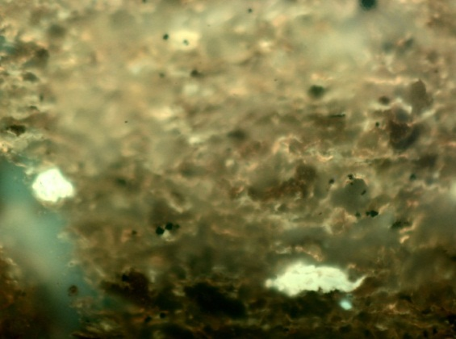
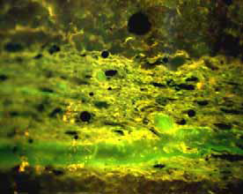

(a)(b)

Figure 6. (a). Photomicrograph of lamalginite set in oil shale sample of the Sangkarewang Formation, Ombilin area (Fluorescence mode). (Source Fatimah, 2009). (b). Photomicrograph of lamalginite (lamelar form) and (?)Botryococcus-telalginite (subrounded form) set in oil shale of Kiliran Formation (Fluorescence mode).

On the basis of Cook et al. (1981), Hutton (1987) and Hutton et al. (1988) terminologies, due to the organic matter comprises predominantly algae of typical lamalginite, along with a very minor amount of probable Botryococcus telalginite, the shales and mudstones of Sangkarewang and Kiliran Formations can be classified as lamosites of Rundle-type. Hutton (1987) indicated that the Rundle-type oil shales were derived mainly from green algae deposited in a fresh to brackish lacustrine condition. Thereby, the Sangkarewang (Talawi and Lubuktaruk) and Kiliran Formation were deposited in a fresh to brackish lacustrine environment.
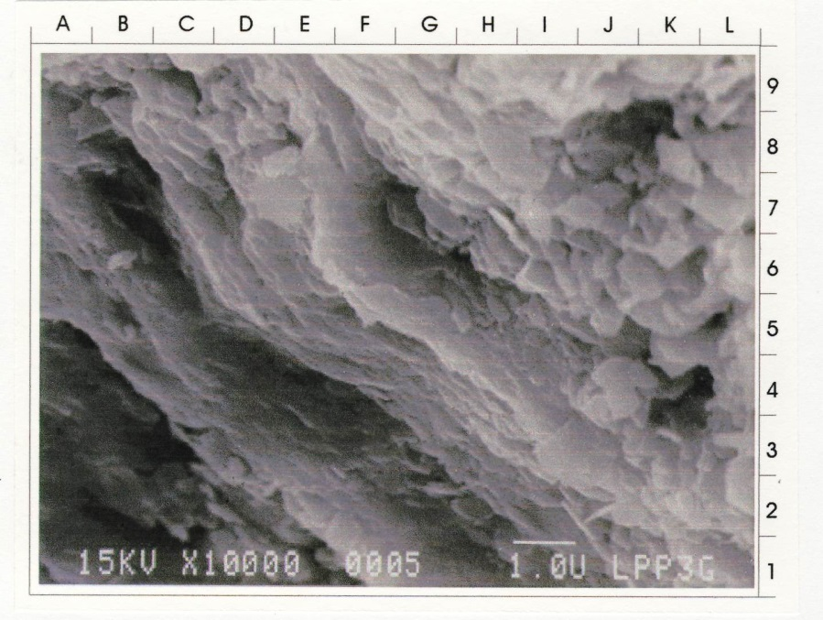

Figure 7. SEM photomicrograph of shale showing organic matter of typical lamalginite (A-E, 1-2) (Suwarna et al., 2000).

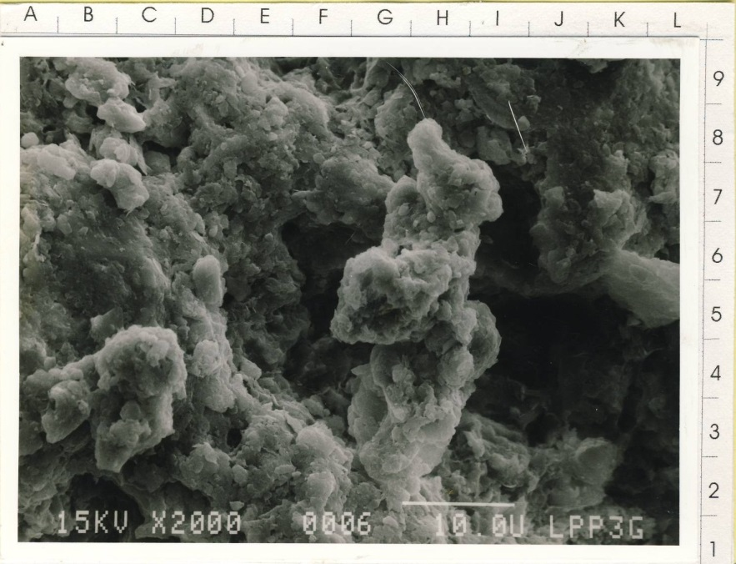

Figure 8. SEM photomicrograph of organic matter of typical alginite (?Botryococcus) (B-C, 3-4, and G-I, 3-8) and some drop oil (bitumen) within disordered kaolinite of Kiliran oil shale (Suwarna et al., 2000).

Table 4. SEM Characteristics of Some Selected Oil Shales of the Sangkarewang and Kiliran Formations (Suwarna et al., 2000 and 2001)
Sample Number | Lithology | Clay Mineral | "Fossil Fuel" emelent | Diagenesis Character | Diagenesis Regime | Remaks
NS. 06 A 1 * Tg. Balit | Claystone / mudstone | Mixed kaolinite and smectite. | Abundant alginite of typically "Pediastrum". | Compact, dense, the presence of clay minerals (kaolinite, smectite) and micropores among clay minerals. | Late Eodiagenesis to Early Mesodiagenesis. | Had been buried of not more than 1000 m deep.
NS. 08 A (*) S. Sipang | Shale | Smectite, minor illite and kaolinite. | Alginite of typically Pediastrum (lamalginite). | Compaction, the presence of clay minerals (smectite, and minor illite and kaolinite). | Eodiagenesis - Early Mesodiagenesis. | Probably had been buried of less than 1000 m deep.
NS. 08 L (*) S. Sipang | Mudstone | Smectite-illite, and kaolinite. | Alginite (lamalginite) | Compaction and dense the presence of smectite-illite, and kaolinite. | Early Mesodiagenesis. | Had been buried of less than 1000 m deep.
NS. 12 A (*) Bt. Porogadang) | Shale | Smectite-illite. | Alginite of "Pediastrum" type (lamalginite). | Compact and dense, directed clay minerals, and the presence of smectite and illite. | Early Mesodiagenesis. | Had been buried of more than 1000 m deep.
NS. 12 E 4 (*) (Bt. Porogadang) | Sandstone, fine-grained | Smectite, illite, and minor kaolinite. | Many vitrinite and liptinite as sporanite. | Compaction and the presence of clay minerals (smectite-illite). | Late Eodiagenesis to Early Mesodiagenesis. | Had been buried of more than 1000 m deep.
NS. 18 A (*) S. Sangkarewang | Sandstone | Kaolinite and smectite-illite. | Rare to absent. | Compaction, the presence of clay minerals (smectite-illite and kaolinite). | Late Eodiagenesis to Early Mesodiagenesis. | Probably had been buried of not more 1000 m deep.
RH. 02 A (*) Padang-ganting) | Shale | Smectite-illite, and a little kaolinite. | Abundant lamalginite, typically "Pediastrum". | Compact, dense, the presence of clay minerals (smectite-illite), and micropores among them. | Late Eodiagenesis to Early Mesodiagenesis. | Probably had been buried of not more 1000 m deep.
HR. 01 E (*) Setangkai (Atar) | Claystone / mudstone. | Kaolinite. | Rare lamalginite. | Compaction and the presence of kaolinite. | Late Eodiagenesis to Early Mesodiagenesis. | Probably had been buried of not more than 1000 m deep.
NS. 13 C (**) Kunangan | Shale | Smectite-illite, rare kaolinite. | Abundant lamalginite, typically "Pediastrum". | Compaction and the presence of smectite-illite. | Mesodiagenesis. | Probably had been buried of more than 1000 m deep.

Comparing to the data presented by the authors in the paper, based on rock-eval pyrolysis data, Widayat et al. (2013) who also studied oil shales in Kiliran and Ombilin Basins, in the view points of their organic matter contents, show an almost similar characteristic results.
They stated, that T_{max} of oil shale exhibit 430ºC and 436ºC for Kiliran and Ombilin, respectively.Vitrinite reflectance values around 0.37%. Therefore, it can be suggested that the oil shales of both areas are immature, whilst the maturity of Ombilin oil shale is slightly higher than that of Kiliran oil shale. Total organic carbon (TOC) values of Kiliran area ranging from 2.10% to 10.94%, averaging at 5.61%, and of Ombilin oil shale varying from 3.55% to 5.87%, of 5.01% in average, tend to indicate that the oil shales can be defined asorganic-rich substances containing significant amounts of oil- to gas-prone kerogen which can produce oil upon heating. Tissot and Welte (1984) stated that oil shale containing organic matter typically > 5%, can be defined as alternative sources for fossil fuels.
Both oil shales are immature source rocks, shown by the generally low production index (PI).The kerogen contents are of type I – II, which tend to indicate more oil- than gas-prone.

Summarizing the three studied areas, the kerogen contained in oil shales is mainly included into Type II, with minor Type I (Figure 5). The oil shales contain both autochthonous and allochthonous organic material. The autochthonous materials consist of Type I kerogen, alginite, and exsudatinite, whilst, the allochthonous type comprises Type II kerogen, sporinite, cutinite, resinite, and vitrinite, of floral/humic origin. By using a combination of TOC, PY, and HI values, in accordance with Rad’s parameter (1984) the oil shales of the three areas studied falls on fair to good category, oil-prone with minor gas-oil prone potential, situated within thermally immature level. Based on Espitalie et al. (1977) and Peters (1986) statements, the pyrolysis yield of >10 mg HC/g rock, tends to indicate that the oil shale is classified as a very good or excellent source-rock potential, which also can be classified as an ‘effective source-rock’. It is also supported by Peters’ observation (1986 and 1989), that rocks with HI>300 mg HC/g TOC will produce oil. Additionally, the thermal maturity of the samples, in general, is included into immature stage. However, some samples show an early mature stage.
The T_{max} values vary from 431° - 432º C (Table 1; Figure 5) and most vitrinite reflectance value ranges between 0.20 % to 0.26 %. These vitrinite reflectance values fall beyond the “oilbirth" line occupying the non-onset oil zone. Sample NS.14i has a slightly higher reflectance indicating that it is close to the oil "birth" line, although still within the non-onset oilarea. The majority of PI values of the samples that are less than 0.1 (Table 1), indicate that the Kiliran oilshales are situated within an immature stage. Overall, the vitrinite reflectance agree with the T_{max} and PI values. Due to their Rv_{max}values (<0.4 %), according to the Foscolos et al.'s chart (1976), the oil shales had undergone aneodiagenetic process.

CONCLUSIONS
Some conclusions regarding the oil shale studied in three areas,can be described as follows:
- Oil shales from Talawi, Lubuktaruk, and Kiliran areas, have excellent to fair hydrocarbon potential level.
- The kerogen contained is included into Type I and II.
- The oil shales of the three areas studied can be categorized as oil-prone source-rock, with thermal maturity varies from immature to early mature level.
- The maceral composition of oil shales in the studied areas is dominated by exinite group mainly lamalginite along with minor Botryococcus-telalginite, liptodetrinite, sporinite, cutinite, resinite, and bituminite. Mineral matter present are mainly framboidal pyrite.
- The majority of oil shales can be termed as “lamosites” of Rundle-type.
- The oil shale classified as a very good or excellent source-rock potential, which can be classified as an ‘effective source-rock’.
- Depositional environment of the oil shales were fresh to brackish lacustrine zones.

Acknowledgment
The previous research was performed by the GRDC Team during 2000 and 2001. The recent research was carried out on 2013 in PTBA-UPO and in 2014 at PT. Karbindo Abesyapradhi and KUD Kunangan Coalfields. The authors wish to acknowledge the facilities provided by the managers of those three coal companies. The acknowledgment would not be complete without expressing thanks to colleagues who support and encourage during the research.

References
Bustin, R.M., Cameron, A.R., Grieve, D.A., and Kalkreuth, W.D. ,1985. Coal Petrology: Its Principles, Methods and Applications. Geological Association of Canada, Short Course Notes, 3, 2nd ed., 273 pp.
Cameron, N.R., Aspden, J.A., Suwarna, N., and Suharsono, 1981. The Geology of Ombilin Basin, Singkarak Block, West Sumatra. Unpublished Rept., P.T. Caltex Pacific Indonesia, Nov. 1981, Rumbai, Sumatra.
Cook, A.C., Hutton, A.C., and Sherwood, N.R., 1981. Classification of oil shales. Bull. Cent. Rech. Exploration-Production Elf-Aquitaine, 5, p.353-381.
Coster, G.L. de , 1974. The geology of the central and south Sumatra basins. Indonesian Petroleum Association, p.77-110.
Dyni, J.R. ,2004. Oil Shale. Energy Minerals Division. EMD Home > Technical Areas: Oil Shale, 10 pp.
Espitalie, J., Laporte, J.L., Madec, M., Marquis, F., Leplat, P., Paulet, J. and Boutefeu, A., 1977. Methode rapide de caracterisation des roches meres, de leur potentiel petrolier et de leur degre d’evolution. Rev. Inst. Franc. Petrole, 32, p.1, 23-40.
Foscolos, A.E., Powell, T.G., and Gunther, P.R.,1976. The use of clay minerals and inorganic and organic geochemical indicators for evaluating the degree of diagenesis and oil generating potential of shales. Geochimica et Cosmochimica, Acta, 40, p.953-966.
Hermiyanto, M. et al. ,2008. Laporan penelitian geodinamika Cekungan Sumatra Selatan di daerah Sinamar, Jambi. Laporan internal PSG.
Heryanto, R., Suwarna, N., and Panggabean, H., 2002. The Lakat Formation in the Northeastern Flank of the Tigapuluh Mountains and Its Possibilities as a Source Rock.Proceedings of 30th Annual Convention Indonesian Association of Geologist and 10th Geosea Regional Congress on Geology, Mineral, and Energy Resources.
Hutton, A.C. , 1980. Organic petrology of some Australian and overseas oil shales. In: Cook, A.C. and Kantsler, A.J. (eds.), Oil Shale Petrology Workshop, Wollongong, 1980. Keiraville Kopiers, Wollongong, p.42-49.
Hutton, A.C., 1987. Petrographic classification of oil shales. International Journal of Coal Geology, 8, p.203-......
Koning, T., 1985. Petroleum geology of the Ombilin Intermontane Basin, West Sumatra. Proceedings, 14th Annual Convention of Indonesian Petroleum Association, Jakarta, October, p.117-137.
ICCP, International Committee for Coal Petrology, 1963. Handbook, 2nd Edition, Centre National de la Recherche Scientifique, Paris, France.
ICCP, International Committee for Coal Petrology, 1971. International Handbook of Coal Petrology, 1st supplement to 2nd edition. Centre National de la Recherche Scientifique, Paris, France.
Peters, K.E., 1986. Guidelines for evaluating petroleum source rock using programmed pyrolysis. American Association of Petroleum Geologists, Bulletin, 70, p.1-36.
Rad,F.K., 1984. Quick Look Source Rock Evaluation by Pyrolysis Technique. Proceedings of 13th Annual Convention of Indonesian Petroleum Association, p.113-124.
Robert, P., 1981. Classification of Organic Matter by Means of Fluorescence: Application to Hydrocarbon Source Rocks. International Journal of Coal Geology, 1, p.101-137.
Sappal, K.K., 1986. Petrography of Collie Coal, Collie Basin, Western Australia. WAMPRI, 26, 202pp.
Silitonga, P.H. and Kastowo, 1995. Geological Map of the Solok Quadrangle, scale 1: 250 000. Geological Research and Development Centre, Bandung (2nd Edition).
Struckmeyer, H.I.M. and Felton, E.A., 1990.The use of organic facies for refining palaeoenvironmental interpretations.A case study from the Otway Basin, Australia. Australian Journal of Earth Sciences, 37, 321-370.
Suwarna, N. , Panggabean, H., and Heryanto, R., 2000. Penelitian Oil Shale Sumatera Bagian Tengah. Laporan Internal, PSG.
Suwarna, N., Heryanto, R., Hermanto, B., Sundari, D., and Panggabean, H., 2001. Paleontolgy and Fossil Fuel Study in Central Sumatera. Internal Report, PSG.
Suwarna, N., Panggabean, H., and Heryanto, R. , 2001. Oil Shale Study in the Kiliranjao Sub-basin, Central Sumatera.Proceedings, IAGI and GEOSEA, Yogyakarta, Indonesia.
Widayat, A.H., Anggayana, K., Syafrizal, Heriawan, M.N., Hede, A.N.H., and Al Hakim, A.Y., 2013. Organic Matter Characteristics of the Kiliran and Ombilin Oil Shales. Procedia Earth and Planetary Science, 6,p. 91 – 96
Wilson, M.D. and Pittman, E.D. (1979) Authigenic clays in sandstone: Recognised and influence on reservoir properties and palaeoenvironmental analysis. Journal of Sedimentary Petrology, 47, p.3-31.

