SUPPLEMENTARY INFORMATION
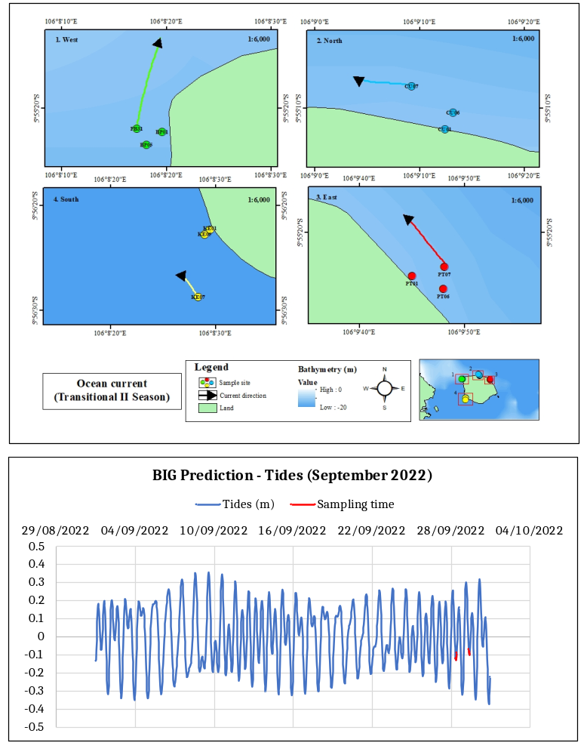
Figure S1. Top: Ocean current during transitional II season at Panjang Island (field measurement)
1: West part. 2: North part. 3. East part. 4. South part. Bottom: Tides from BIG Prediction in September 2022

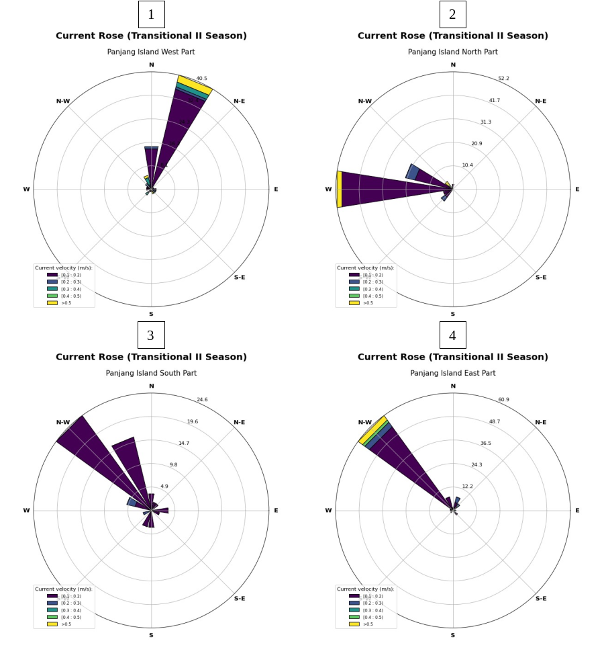
Figure S2. Current rose during transitional II season at Panjang Island (field measurement). 1: West part. 2: North part. 3. East part. 4. South part

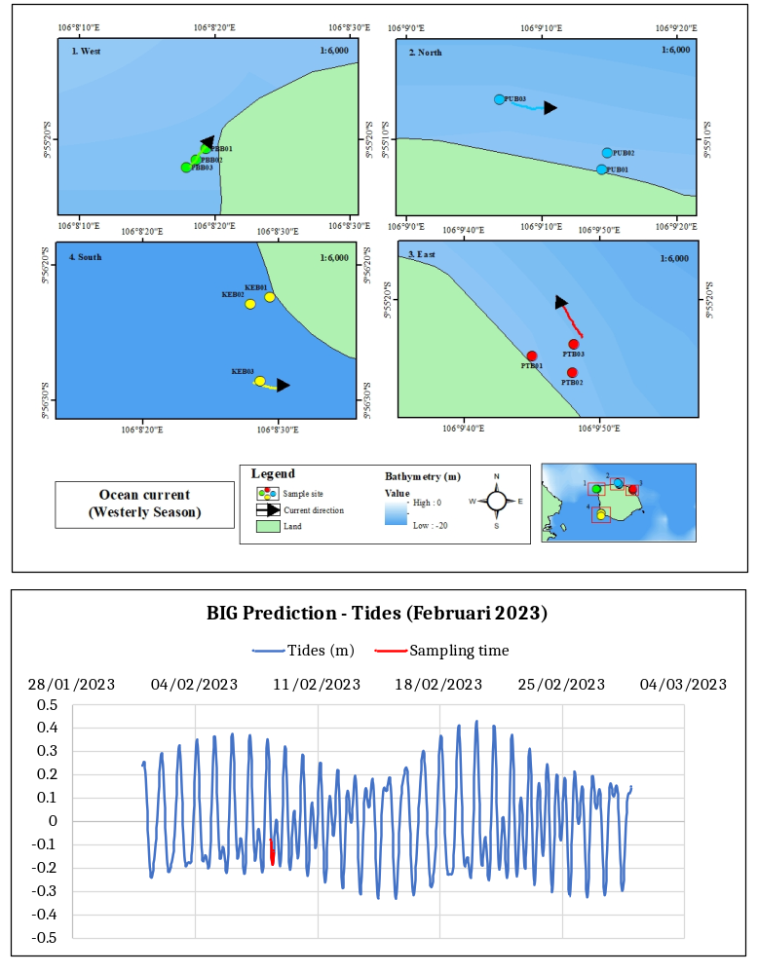
Figure S3. Top: Ocean current during westerly season at Panjang Island (field measurement).
1: West part. 2: North part. 3. East part. 4. South part. Bottom: Tides from BIG Prediction in February 2023
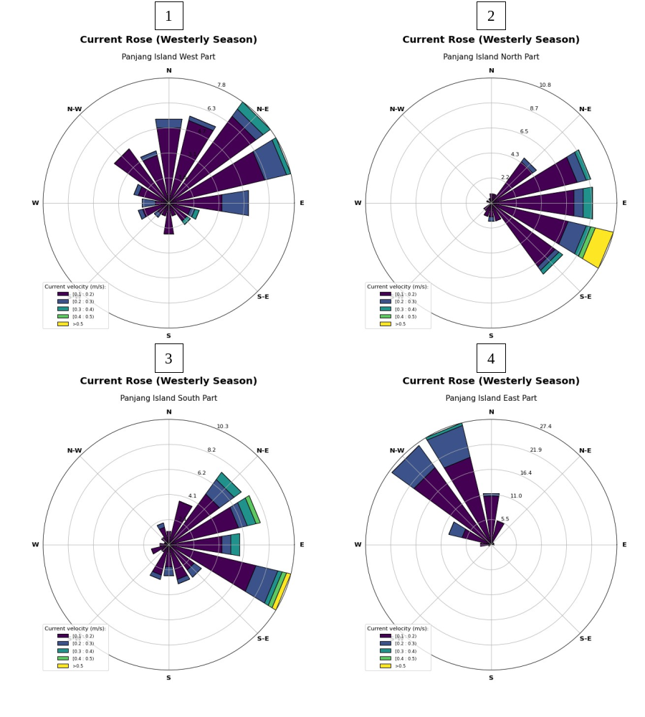
Figure S4. Current rose during westerly season at Panjang Island (field measurement). 1: West part. 2: North part. 3. East part. 4. South part

