SUBSURFACE CONCEPTUAL LRP (LOW RESISTIVITY PAY) ZONE DEVELOPMENT OF THE OLIGO - MIOCENE RESERVOIR TALANGAKAR FORMATION WIDURI AREA, ASRI BASIN, SOUTHEAST SUMATRA BLOCK, INDONESIA

KONSEPTUAL SUBSURFACE LRP (LOW RESISTIVITY PAY) DARI PERKEMBANGAN ZONA OLIGO - MIOCENE FORMASI RESERVOIR TALANGAKAR WIDURI AREA, CEKUNGAN ASRI, SOUTHEAST SUMATRA BLOCK, INDONESIA

Dwandari Ralanarko¹, Pranowo Nugroho¹, Edy Sunardi², Ildrem Syafri², Billy G. Adhiperdana²
¹ Pertamina Hulu Energi OSES, Menara Standard Chartered, Jl. Prof. Dr. Satrio No.26, Karet Semanggi, Setiabudi, Jakarta Selatan, DKI Jakarta 12950
² Post-Graduate Program, Faculty of Geological Engineering – Universitas Padjadjaran, Jl. Raya Bandung – Sumedang KM 21, Jatinangor, Jawa Barat 45363

ABSTRACT
Southeast Sumatra is a prolific oil and gas block, located offshore of the Java Sea, 90 kms the northern part of Jakarta Bay. This area covers two major basins, namely Sunda Basin and Asri Basin. Initial development of the area focused on conventional closures and high-resistivity reservoirs. Further analysis shows that there are special low-resistivity reservoirs in Widuri Area, especially the Aryani field. This paper will discuss about reservoir identification of low resistivity pay zone reservoirs in the area, and fluid containment of the intervals. The paper will also cover the interval ability to produce oil and the upside potential of the reservoirs using current geological, geophysical, and reservoir engineering approaches and will describe operational challenges faced during the production period.

The low resistivity pay zone in the Aryani field of the Widuri area is identified using gas reading in the daily drilling reports complemented with mud logging data. The interval, basal sand, drapes above the basement. Aryani AC-X, preceded by a hydraulic fracturing job, is the first producing well of basal sand. Lambda-mu-rho inversion is implemented to delineate this reservoir. Reconfirming data between elan summary, sidewall core and cutting data is conducted to recognize the potency in those wells. Aryani AC-X has successfully drained oil using a submersible pump, with initial production of 408 bopd and cumulative production of 240 MBO.

Keywords: Asri Basin, Indonesia, low resistivity, Oligo-Miocene, reservoir, Talangakar Formation

ABSTRAK

Southeast Sumatra adalah blok minyak dan gas yang produktif, terletak di lepas pantai Laut Jawa, 90 km bagian utara Teluk Jakarta. Daerah ini mencakup dua cekungan utama, yaitu Cekungan Sunda dan Cekungan Asri. Pengembangan awal area ini difokuskan pada penutupan konvensional dan reservoir-reservoir dengan resistivitas tinggi. Analisis lebih lanjut menunjukkan bahwa terdapat reservoir-reservoir khusus yang berresistivitas rendah di daerah Widuri, terutama lapangan Aryani. Makalah ini akan membahas tentang identifikasi reservoir zona reservoir pay-zone resistivitas rendah di daerah tersebut, dan penahanan fluida pada interval-interval tersebut. Makalah ini juga akan membahas kemampuan interval untuk memproduksi minyak dan potensi upside dari reservoir dengan menggunakan pendekatan geologi, geofisika, dan rekayasa reservoir saat ini, serta akan menjelaskan tantangan operasional yang dihadapi selama periode produksi.
Zona pay resistivitas rendah di lapangan Aryani di area Widuri diidentifikasi menggunakan pembacaan gas dalam laporan pengeboran harian yang dilengkapi dengan data mud logging. Interval tersebut, basal sand, membentang di atas basement. Aryani AC-X, yang didahului dengan pekerjaan rekah hidrolik, merupakan sumur produksi pertama dari basal sand. Inversi Lambda-mu-rho diimplementasikan untuk mendelineasi reservoir ini. Rekonfirmasi data antara elan summary, sidewall core dan data cutting dilakukan untuk mengetahui potensi di sumur tersebut. Aryani AC-X telah berhasil mengalirkan minyak dengan menggunakan pompa submersible, dengan produksi awal 408 bopd dan produksi kumulatif 240 MBO.
Kata Kunci: Cekungan Asri, Indonesia, Resistivitas Rendah, Oligo-Miosen, Reservoir, Formasi Talangakar

INTRODUCTION
Southeast Sumatra production sharing contract is located in Offshore Sumatra, operated by Pertamina Hulu Energi OSES. Three basins of Sunda, Asri, and Hera lie in an area of 11,046 sq. km of concession. Asri Basin was once thought to have low maturity of source rocks resulting in a low interest to be explored, during the early stage, from 1983 to 1987 (Wight et. al., 1997).

A Cenozoic extensional back-arc and half-graben rift of Asri Basin (Young and Atkinson, 1993) is situated in Offshore Sumatra, Indonesia, and covers an area of approximately 3500 sq. km. It comprises thick sediment from Paleocene to Pleistocene up to 16,000 ft in thickness. It is bordered by a downthrown to the west, N-S trending faults to the East, and an NW-SE trending wrench system to the south (Ralanarko et. al., 2020).

Three major tectonics are recognized: pre-rift, syn-rift, and post-rift, which affected the structural style and depositional systems in the Asri Basin (Ralanarko et. al., 2020). The basin-acknowledged oil fields have a stratigraphic aspect that is influenced by moderate intra-basinal faulting and folding. Structural control on major axial drainage systems would exert tremendous influence on sand supply to any particular basin at any given time. Basin integration and its control of axial fluvial systems play an important role in a fluvial deposition during basin evolution and fill. The Lower Zelda and Upper Gita Members are the main components of the Oligocene TAF (Aldrich et. al., 1995). Asri Basin location and Regional Stratigraphy are shown in (Figure 1).
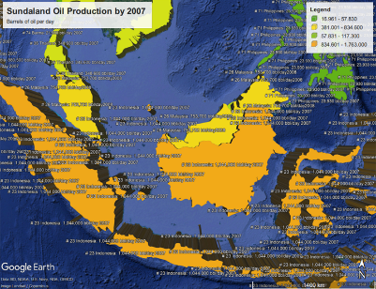
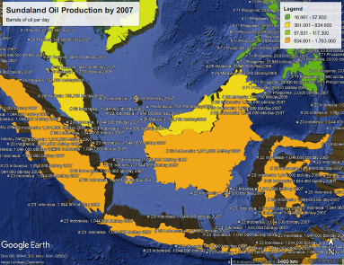
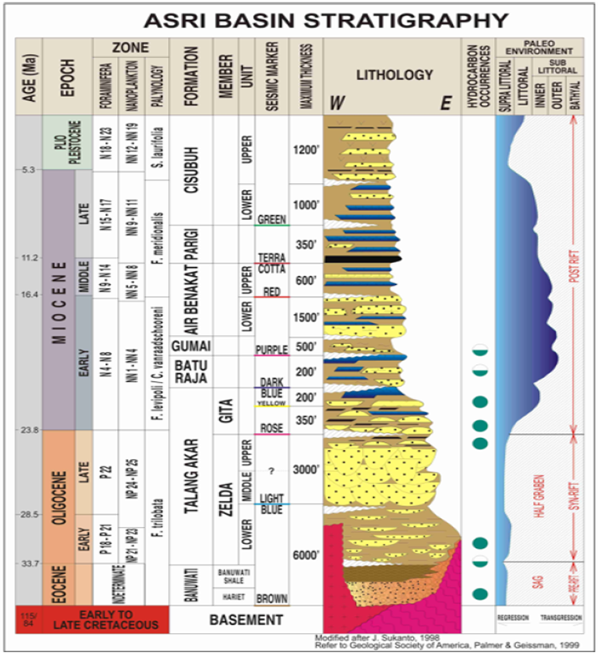
Figure 1. Asri basin location and regional stratigraphy (Ralanarko et. al., 2020)

The main objective of this research is early syn-rift basal sand interval, especially in the Aryani field. This reservoir is located above the basement fault and has a distinctive character, with a thickness of about 10 ft. Resistivity log patterns are relatively flat and do not show any contrast with the layer above. However, the density log indicated a strong contrast with the layer above. The difference in trend between both logs is assumed to be attributed to the content of certain minerals that affect the resistivity log readings.

METHODS

The basal sand reservoir in the Aryani field has produced about 215 MBO from the A-05 well since it was first drilled in 2007. Because only one well in the reservoir is producing and the average permeability is relatively low to medium, some infill wells are needed to optimize the production. The addition of well/infill drilling requires integrated reservoir characterization.
The study includes integrated geological modelling with seismic attributes to determine the lateral distribution of the basal sand reservoir. Vertical distribution-specific methods are needed because the Volume of Clay (VCL) and Gamma Ray (GR) VCL and GR logs are not sufficient to separate thin layers in detail. In this study, we determined the reservoir characteristics using Rock Typing (RT) methods. RT methods are used for classifying an interval that has similar characteristics in a particular zone. This process is called a Cluster Analysis. This method is based on statistical algorithms that classify well logs data that are similar in character. We later determined the zones along the wells characterized by grain size, grain shape, and sorting characteristics.

2.1. Geophysical Aspect

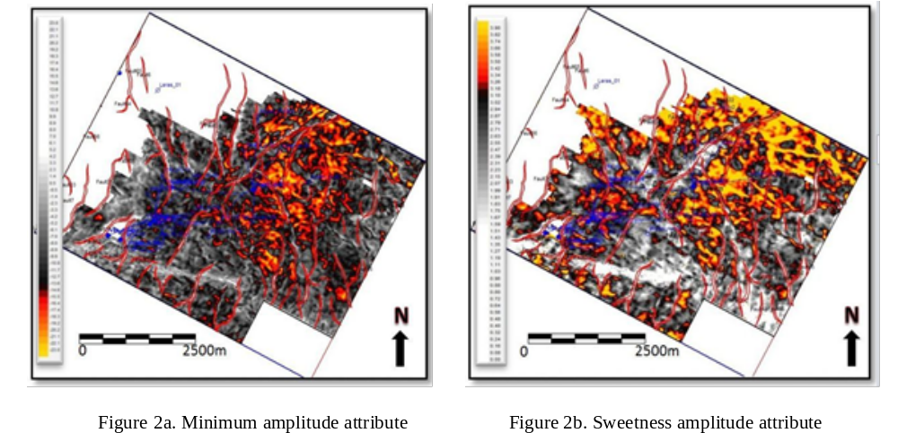
Basal sand is represented by a peak amplitude (a positive value means increased impedance) interfering with the basement reflector. Amplitude attribute analysis was performed to determine the amplitude response of the basal sand. The minimum and sweetness amplitude attributes are shown in (Figure 2a) and (Figure 2b). Unfortunately, the result was not good enough to determine the lateral distribution of the basal sand. After crosschecking with the presence of basal sand, many inconsistencies cannot be interpreted from the amplitude attributes. The common interpretation for predicting this basal sand is using isochrones from the Top Lower Zelda to the Top Basement as shown in (Figure 3). This is interpreted as the paleo-structure, especially on the basal sand distribution that drapes above the basement, controlling the depositional periods for the Lower Zelda member.
Figure 2a. Minimum amplitude attributes Figure 2b. Sweetness amplitude attribute

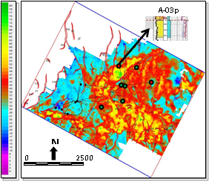
Figure 3. Isochrones interval Top Lower Zelda to the Top Basement

From this interpretation, the boundary of the lower Zelda member geometry has an NW–SE trend but for the basal sand distribution, there is still an inconsistency between the well data and the isochrones maps. An integrated geophysical analysis is needed for basal sand reservoir characterization.

2.2. Geological Aspect

Several RT methods are commonly used; two are the flow-zone indicator, RQI/FZI, and the pore-throat radius, Winland’s R (35) (Guo et al., 2005). Both methods are applied to this case study. Based on the test results, the RQI/FZI is more in line with the Aryani field data. This is possible because the characteristics of clastic reservoirs in the Aryani field are influenced by the texture, so permeability should correlate well with porosity. The permeability is obtained from core data and distributed to the uncored well using the equation from the porosity and permeability cross plot. The ratio of RQI/FZI can be used to calculate rock typing (Amaefule et al., 1993). RQI is a rock-quality index given by:
RQI = 0.0314 $√\frac{k}{∅_{e}}$
Where k is permeability from the Kint log, and ∅e is effective porosity. ∅e can be obtained from ∅z, the normalized porosity index, where:
$$∅_{z=(\frac{∅_{e}}{1-∅_{e}})}$$
So the flow zone indicator formula is:
FZI = $\frac{RQI}{∅_{Z}}$.

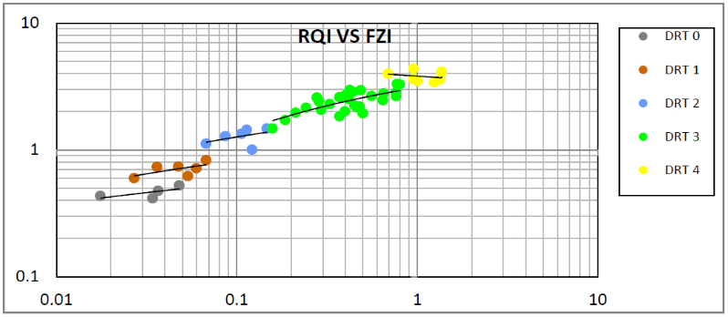
The value of FZI is divided into several intervals, which are considered to be of the same unit based on the cutoff obtained from the FZI versus RQI graph from the A-05 well (Figure 4) and (Figure 5). Five different rock types can be classified based on the value of FZI. Different permeabilities of RT 0 – 4 also show the quality of each reservoir interval. The cutoff was applied to all wells in the Aryani field. This result was used as input for the geological model. The RT method is effective enough to classify thin layers of basal sand. The ratio method of RQI/FZI showed a good correlation between the porosity and permeability to identify some rock types. This shows the texture of the rock has a role in distinguishing some rock types as shown in (Figure 6).
Figure 4. Correlation between RQI vs FZI based on RT classification

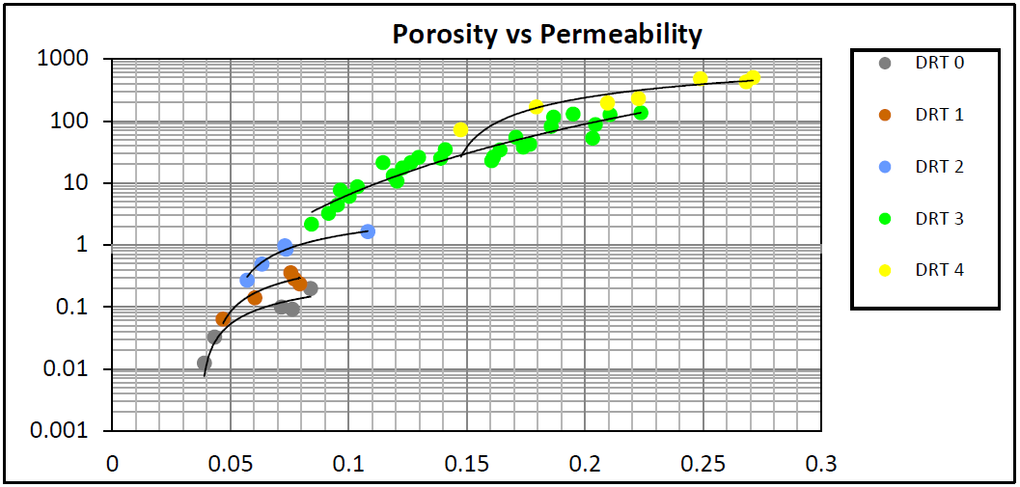
Figure 5. Correlation between porosity and permeability based on RT classification
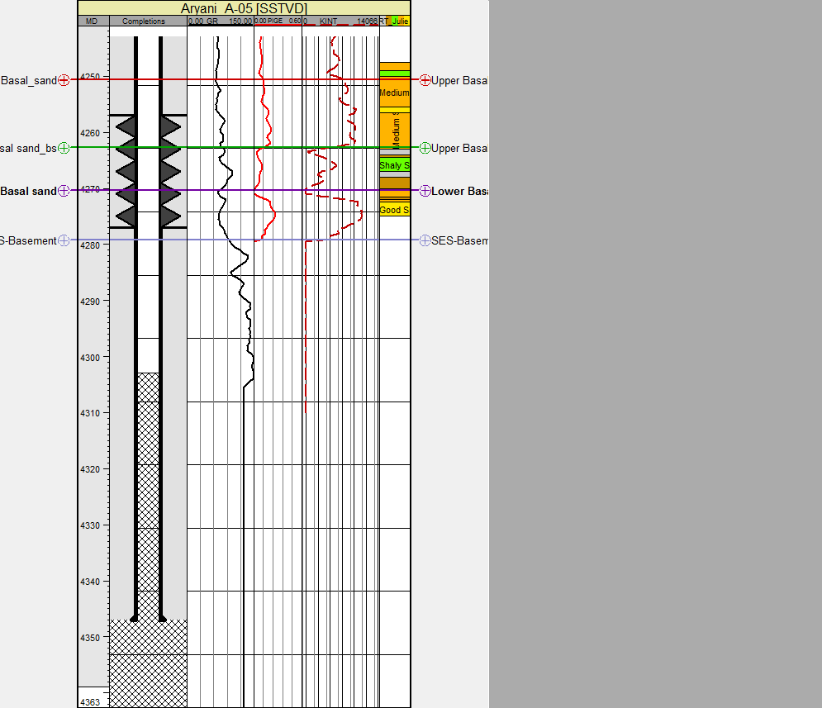
Figure 6. Correlation between porosity, permeability, RQI, and FZI based on RT classification

2.3. Data Analysis

Model-based inversion is one way to see the distribution of the reservoir. A feasibility study was undertaken on well A-05, showing that the crossover of AI and SI successfully separates the basal sand in log resolution. From the generated AI map, the basal sand distribution does not give a more detailed trend compared with the previous interpretation and has a poor correlation with the sand presence already known from the well data. Further analysis using the elastic properties, such as an AVO analysis and the Lame parameter, Lambda–Rho (LR), and Mu–Rho (MR), is necessary. The feasibility test on AI vs SI crossplot is shown in (Figure 7). AI map on the basal sand reservoir is shown in (Figure 8). Intercept (P) and Gradient (G) volume can be derived from gathered data. Near the basement indicates that positive P value/red and a negative value of G / blue. P*G results indicate a negative value/blue. Results of cross plot P vs G volume indicated by the yellow colour which indicates the distribution of basal sand. P vs G volume is shown in (Figure 9).
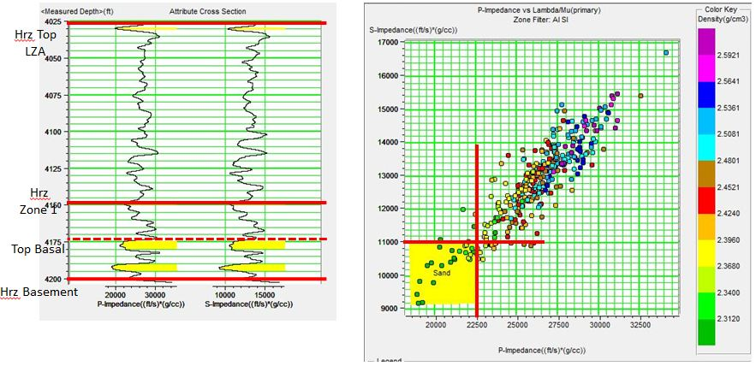
Figure 7. Feasibility test on AI vs SI crossplot
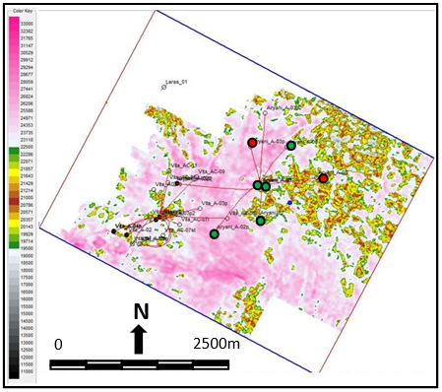

Figure 8. AI map on basal sand reservoir

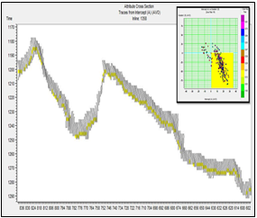
Figure 9. P vs G volume indicated by yellow colour
The P-reflectivity (Rp) and S-reflectivity (Rs) data can also be derived from seismic data. LR and MR can be derived by doing an AVO inversion on Rp and Rs. The cross-plot result from LR and MR from the A-05 well successfully separated the basal sand, with an LR cut-off from 15–24 GPa*g/cc and an MR from 7.5–12.5 GPa*g/cc.
The LR section and the LR map show a good match with the well data, while the MR result is not sensitive and visibly does not match with well data. The LR map shows the lateral distribution of the basal sand reservoir similar to alluvial fan deposition patterns in the NW–SE trend. This attribute is used as an input for the geological model. The P-reflectivity (Rp) and S-reflectivity (Rs) data can also be derived from seismic data. LR and MR can be derived by doing an AVO inversion on Rp and Rs. The cross-plot result from LR and MR from the A-05 well successfully separated the basal sand, with an LR cut-off from 15–24 GPa*g/cc and an MR from 7.5–12.5 GPa*g/cc.
The LR section and the LR map show a good match with the well data, while the MR result is not sensitive and visibly does not match with well data. The LR map shows the lateral distribution of the basal sand reservoir similar to alluvial fan deposition patterns in the NW–SE trend. These processes are shown in Figure 10 (Intercept & Gradient Volume), Figure 11 (Feasibility test on Lambda-Rho and Mu-Rho), Figure 12 (Lambda-Rho section) and Figure 13 (Lambda-Rho map) shows the lateral distribution similar with alluvial fan pattern and resulted from attribute which is used and utilized as an input for the geological model.

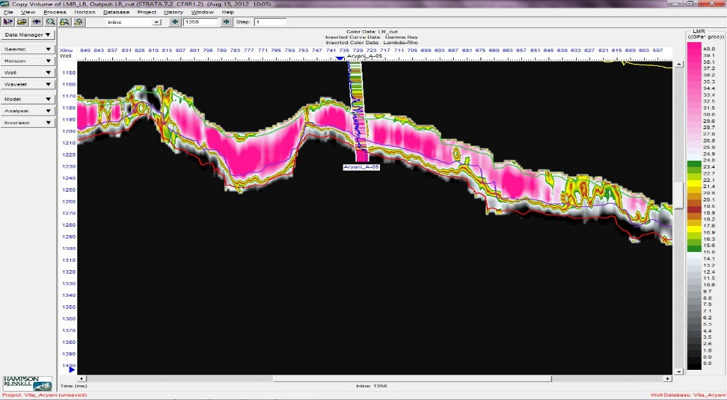
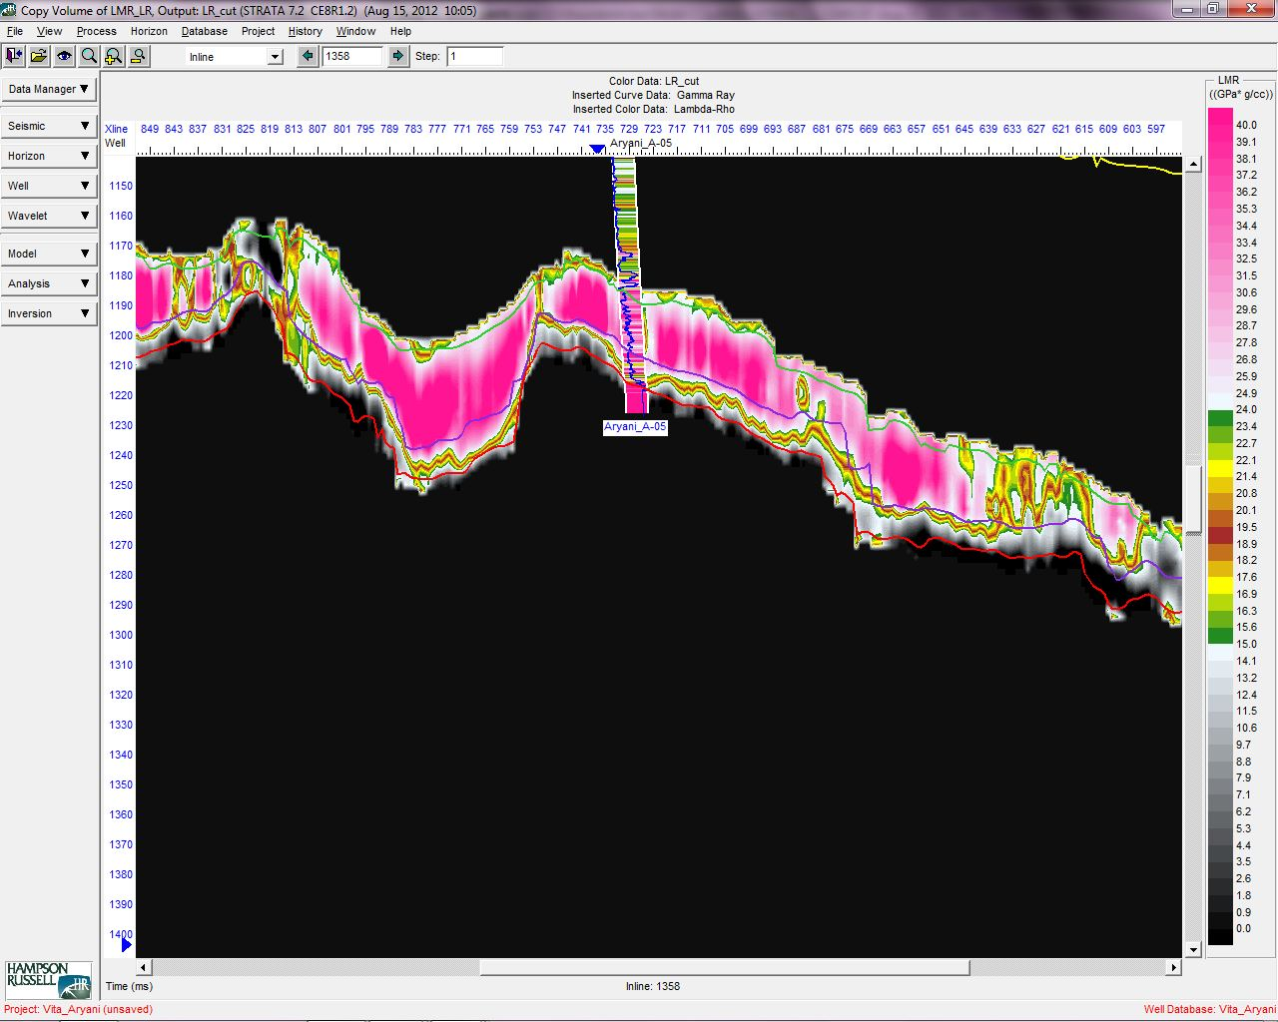
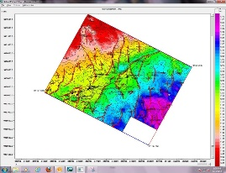
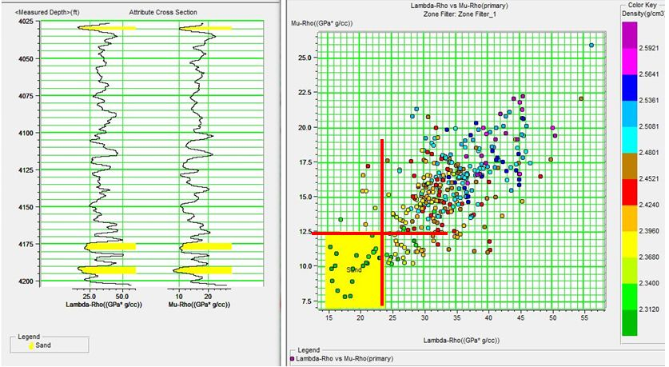
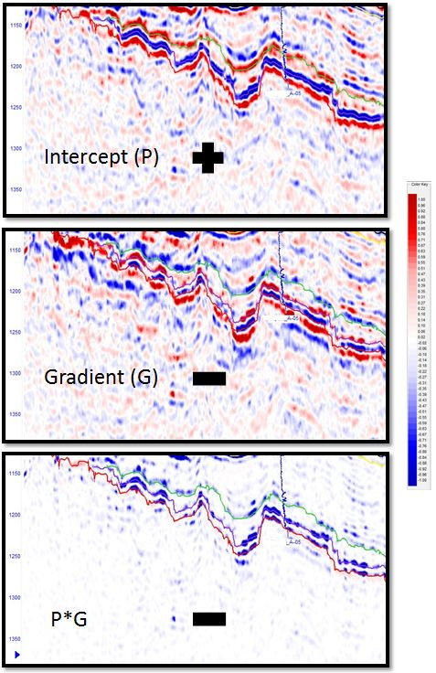
Figure 11. Feasibility test on Lambda-Rho and Mu-Rho
Figure 12. Lambda-Rho section that crosses
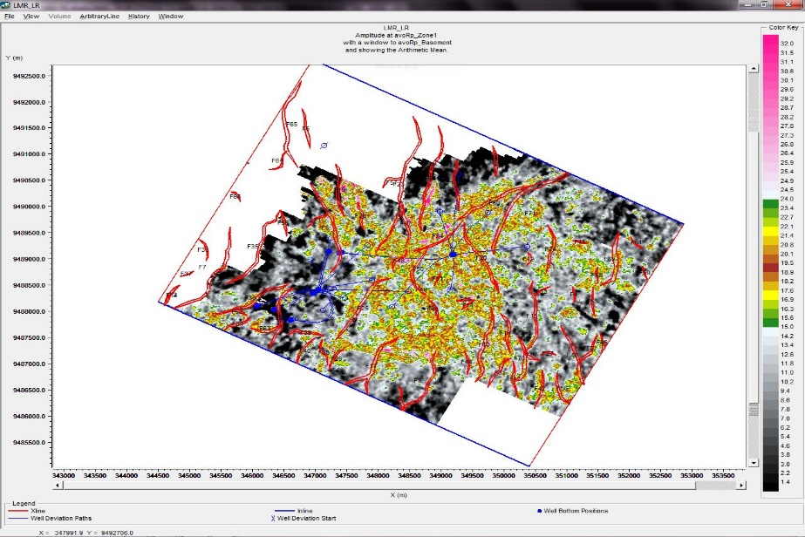
on A-05 well with cut off 15-24 GPa*g/cc
0
2500m
N

Figure 10. Intercept volume (top) shows (+) near the basement, Gradient volume (mid) shows (-), and P*G (bottom) shows (-)

Figure 13. Lambda-Rho map shows the lateral distribution similar with alluvial fan patern

RESULT

The four main components for the construction of a static model are the seismically derived depth horizon, the fault model, layer thickness isochores, and correlated well tops. The basement horizon is the only depth horizon derived from seismic data, and other horizons phantom up using thickness isochores. Eighteen faults are used to generate the fault model and fault segments. The facies model shown in (Figure 14) follows the conceptual depositional model for an alluvial fan system environment. Braided Channel deposits associated with the streamflow are the predominant reservoir facies with a NE–SW flow direction; during stages of flooding, debris-flow and mud-flow sediments have been deposited.
The main challenge is making a 3D geological model when trying to create a model that resembles the actual facies deposition environmental conditions. In the deposition of alluvial fans, channels deposit adjacently and overlay each other. Thus, a stochastic approach is needed that still honors those geological conditions. The combination of Truncated Gaussian Simulation (TGS) and Object Modeling methods are effective for modelling the delineation of the fan lobe and the distribution of the channel within the fan lobe.
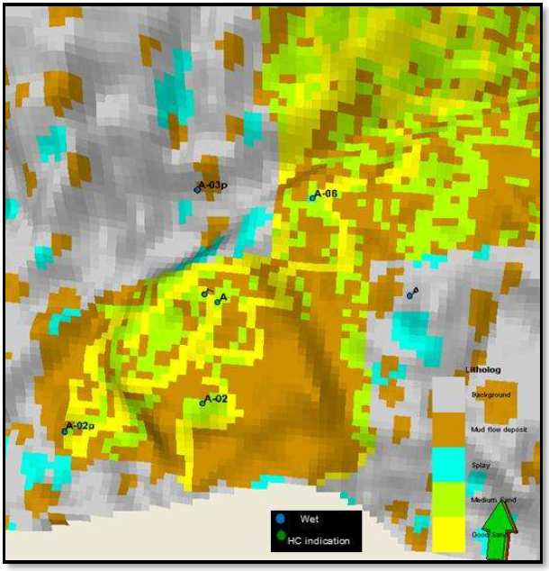
Prior to facies modelling, various trends were prepared to constrain the model geologically. Data analysis of the vertical distribution of reservoir facies illustrated a common trend for most zones, generally, the proportion of sand increases towards the top of the zones. This distinct coarsening upward pattern was considered in the modelling of the reservoir facies. The total volume of clean sandstone distributed in the facies models is controlled vertically by the coarsening upward trends observed in the blocked wells. And the lateral distribution and direction of fan lobe and channels are controlled by the seismic attributes.
Figure 14. Facies model of Alluvial Fan deposit
The distributed volume of debris-flow and mud-flow deposits is controlled by the proportions seen in the wells. It is a conceptual schematic depositional model covering the Aryani field directions within the reservoir area. It is interpreted to be an alluvial fan depositional environment with both fluvial and debris flow deposits. The delineation distribution of the fan lobe follows the trend of seismic attributes.
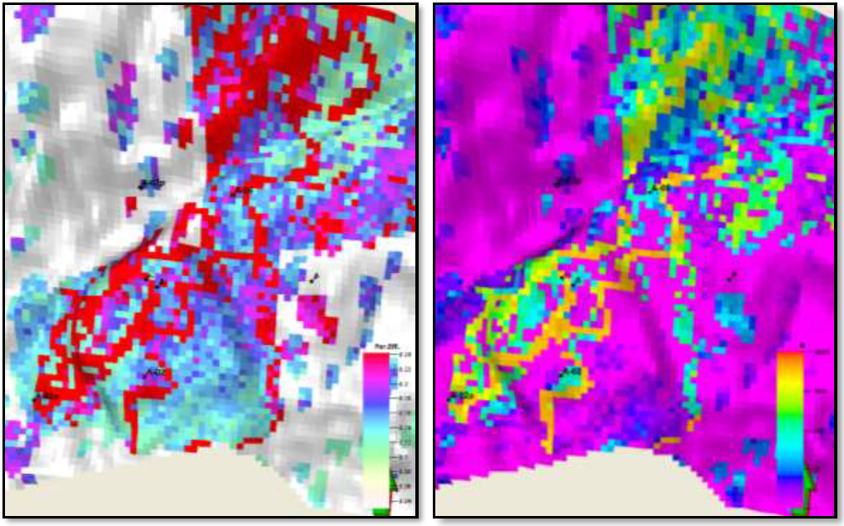
The volume of effective porosity and permeability (Figure 15) was co-simulated stochastically with a bias to the facies model. Each facies has its own petrophysical range, trends, and data distribution, as observed in the statistical data analysis of the upscale well data and reflected in the model volume. Histograms, scatterplots, and data transforms for effective porosity and permeability plots were generated and analyzed for quality control. The distribution of volumes of effective porosity and permeability were compared with the stochastic output parameters to ensure consistency. Stochastic (Gaussian) conditional simulation was chosen to model the petrophysical attributes. In conjunction with the estimated variogram model, the petrophysical input parameter attributes (conditioned 100% to wells) were distributed throughout the model volume.
Figure 15. Porosity model (left) and permeability model (right) of Alluvial Fan deposit in Aryani Field of Widuri Area

DISCUSSIONS

Based on the type of rock in the alluvial fan sediments, the interpreted Rock Type (RT) 0-2 that has an average permeability and porosity values are low, between 6–8% and 0.1–2 mD, and RT 0-3 are interpreted as mud-flow deposition. RT 0-3 has an average permeability value of 42 mD and a porosity of 15% and is interpreted as small channel sediment. Then RT 0-4, which has a relatively high permeability average of about 280 md and a porosity of 22%, is interpreted as the main sediment channel.
Due to the intermittent deposition process, the deposition of alluvial fans is generally not one single body but consists of several overlapping layers of sand. It is seen in the alternation of RT 0-4 which is sometimes very thin in some wells. A conceptual model of alluvial fans shows the details of the three-dimensional (3D) geometry depending on the extent of tectonic activity and the rate and volume of sediment being deposited by the streams. As indicated, alluvial fans are not generally formed as a single body but are built up over time as overlapping deposits. This is also shown in the RT results vertically; where four rock types overlap each other repeatedly.

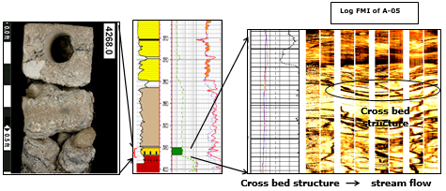
Figure 16. Core data and well logs indicate basal sand deposited in the Mid-Fan
The results of the core data analysis from the A-05 well as a key well indicate that the depositional environment developing in the Aryani field is the alluvial fan as shown in (Figure 16). It contains a wide range of grain sizes and many angular rock fragments. This reflects the fact that the sediments have not been transported very far from their source before being deposited. The nearest high topography is the northern area, and toward to south down fan direction, the mean grain size of the sediment rapidly decreases. Alluvial fans contain a large amount of debris-flow and mud-flow deposits This generates abrupt and erratic changes in facies, both laterally and vertically.

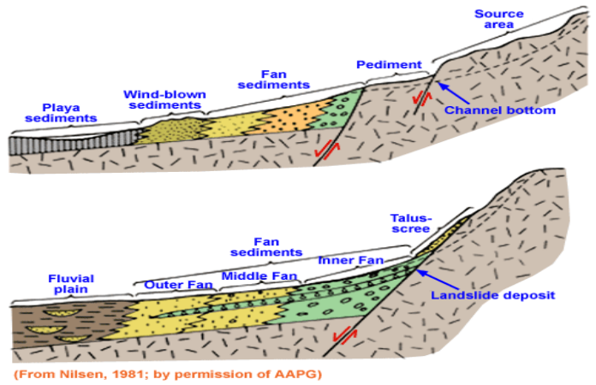
Alluvial fan deposits are not the result of steady deposition. Rather, a series of sporadic events, representing the discharge of an intermittent stream system is the major process. Nilsen (1982), subdivided alluvial fan deposits into two basic types. The first type consists of stream-flow deposits. These result from intermittent streams flowing in poorly defined, braided channels over the surface of the fan. Stream-flow deposits are usually coarse-grained and well sorted and stratified, with much of the clay matrix washed out of them. The second type consists of debris-flow and mud-flow deposits in which a saturated mass of material, often consisting of larger rocks supported in a mud-rich matrix, moves as a sediment gravity flow down the surface of the fan. As a whole, the fan body forms from a complex interlaying of these basic types of sediment. A 3D schematic of the Alluvial Fan environment is shown in (Figure 17).
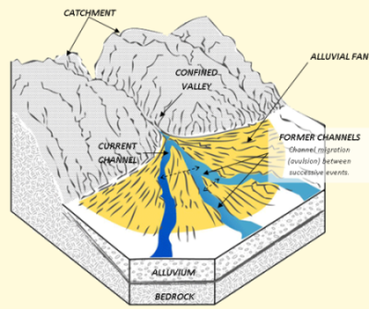

Figure 17. 3D schematic of Alluvial Fan environment (Nilsen, 1982)

CONCLUSION

From this research, the boundary of the Lower Zelda member geometry has defined an NW–SE trend but for the basal sand distribution, there is still an inconsistency between the well data and the isochrones maps. An integrated geophysical and geological analysis has been conducted for basal sand reservoir characterization. A low resistivity reservoir of Oligo-Miocene Talangakar Formation basal sand reservoir in the Aryani field of Widuri Area in Asri Basin has distinctive characteristics need necessary integration analysis to identify the distribution of alluvial fan sediments. By using analysis of elastic properties such as Lambda Mu Rho, the lateral distribution of a thin basal sand reservoir has been resolved as an alluvial fan deposition pattern.

Geocellular modelling is done, using a combination of modelling methods, Truncated Gaussian for geological conditions which have lithological boundaries that are quite firm (hard boundary) and Object Model for the transition boundary (soft boundary). Rock Type and Seismic Attribute methods are provenly effective to classify thin layers of basal sand. The ratio method of RQI/ FZI showed a good correlation between porosity and permeability to identify some rock types. This shows the texture of the rock is quite a role to distinguish some rock types.

ACKNOWLEDGEMENTS

The authors would like to thank the management of Pertamina Hulu Energi OSES, Pertamina EP, Pertamina Sub-holding Upstream (PHE), and SKK MIGAS, for their permission to publish this paper. Thank you to all Geosciences & Reservoir Team of the Subsurface Development Planning Department - PHE OSES, Talangakar Formation Technical Interests Group, all lecturers and civitas academica of Post-Graduate Program, Faculty of Geological Engineering, Universitas Padjadjaran for sharing beneficial, fruitful, and constructive discussions during this research and manuscript preparation.

REFERENCES

Aldrich, J.B., Pinehart, G.P., Ridwan, S., and Schuepbach. M.A. (1995): Paleogene Basin Architecture of the Sunda and Asri Basins and Associated Non-Marine Sequence Stratigraphy, Proceedings of International Symposium on Sequence Stratigraphy, Indonesian Petroleum Association, Jakarta, May 1995, 261-287.

Aki, K., and Richards, P.G. (1980): Quantitative Seismology: Theory and Methods, Vol 1, W.H. Freeman and Co.

Amaefule, J.O, Altunbay, M., Tiab, D, Kersey, D.G., and Keelan, D.K. (1993): Enhanced Reservoir Description - Using Core and Log Data to Identify Hydraulic (Flow) Units and Predict Permeability in Un-cored Intervals/Wells, Society of Petroleum Engineers 26436.

Castagna, J.P., Swan, H.W., and Foster, D.J. (1998): Framework for AVO Gradient and Intercept Interpretation, Geophysics, 63, p948-956.

Gray, F.D. and Andersen, E.A. (2000): The Application of AVO and Inversion to Formation Properties, World Oil, Vol. 221, No. 7.
Guo, G., Diaz, M.A., Paz, F., Smalley, J. and Waninger, E.A. (2007): Rock Typing as an Effective Tool for Permeability and Water-Saturation Modeling: A Case Study in a Clastic Reservoir in the Oriente Basin. SPE Res Eval & Eng 10 (6): 730-739. SPE-97033-PA.

Nilsen, T.H. (1982): Alluvial fan deposits. In Scholle, P.A. and Spearing, P. (eds.), Sandstone Depositional Environments. Memoir: American Association of Petroleum Geologists 31: pp. 49–86.

Ralanarko, D., Syafri, I., Abdurrokhim, and Nur, A.A. (2020): Seismic Expression of Paleogene Talangakar Formation, Asri & Sunda Basins, Java Sea, Indonesian Journal of Sedimentary Geology, ISSN 0853-9413, No. 46, 21-43.

Smith,G., and Gidlow, P. M. (1987): Weighted Stacking for Rock Property Estimation and Detection of Gas: Geophys. Prosp., 35, 993–1014.

Wight, A., Friestad, H., Anderson, I., Wicaksono, P., and Remington, C.H. (1997): Exploration History of the Offshore Southeast Sumatra PSC, Java Sea, Indonesia, in: Petroleum Geology of Southeast Asia, Fraser, Matthews, and Murphy (eds.), Geological Society Special. Publication No. 126, p. 121-142.

Young, R. and Atkinson, C.D. (1993): A Review of Talangakar Formation (Oligo-Miocene) Reservoirs in the Offshore Areas of Southeast Sumatra and Northwest Java. Clastic Core Workshop, Spec. Publication of the Indonesian Petroleum Association, 177-210.

