- RESEARCH INSTRUMENTS
Matlab 2010 and Matlab 2021

- DATA SETS
Table 1. General description of the nine GCMs involved in this study. All models are part ot the PMIP3 which their simulation output are freely accessible in cera-www.dkrz.de. (https://wiki.lsce.ipsl.fr/pmip3/doku.php/pmip3:database:status).
Model name | Country | Number of  horizontal grid and  vertical layers | Length of simulation  per-scenario (Year) |  | Cite
Model name | Country | Number of  horizontal grid and  vertical layers | pre-Industrial | mid-Holocene | Cite
BCC-CSM1 | China | 128 x 64 x L21 | 1500 | 100 | (Wu & Xin, 2015)
CCSM4 | USA | 288 x 192 x L26 | 1503 | 903 | (Otto-Bliesner, 2014)
CESS FGOALS-S2 | UK | 192 x 145 x L38 | 30 | 30 | (LASG 2015)
CSIRO MK-3-6-0 | Australia | 64 x 56 x L1 | 1353 | 153 | (Jeffrey et al., 2016)
IPSL-CM5A-LR | Prancis | 96 x 95 x L39 | 2703 | 1203 | (Braconnot et al., 2016)
MIROC ESM | Japan | 36 x 43 x L40 | 277 | 243 | (JAMSTEC et al., 2015)
MPI ESM-P | Japan | 196 x 98 x L47 | 603 | 273 | (Jungclaus et al., 2012)
MRI-CGCM3 | Japan | 364 x 160 x L48 | 1203 | 273 | (Yukimoto et al., 2015)
NASA GISS-E2-R | USA | 40 x 60 x L40 | 63 | 63 | (NASA 2014)

- RESEARCH ETHICS REVIEW
- < https://www.wdc-climate.de/ui/> [Accessed at 20 August 2021].
- Yukimoto, S., Adachi, Y., Hosaka, M., Sakami, T., Yoshimura, H., Hirabara, M., Tanaka, T., Shindo, E., Tsujino, H., Deushi, M., Mizuta, R., Yabu, S., Obata, A., Nakano, H., Koshiro, T., Ose, T., & Kitoh, A. 2015. MRI-CGCM3 model output prepared for CMIP5 midHolocene, served by ESGF. World Data Center for Climate (WDCC) at DKRZ, https://www.wdc-climate.de/ui/ accessed at 2021-08-20.
- Otto-Bliesner, B. 2014. CCSM4 coupled simulation for CMIP5 with mid-Holocene conditions, served by ESGF. World Data Center for Climate (WDCC) at DKRZ, https://www.wdc-climate.de/ui/ accessed at 2021-08-20.
- NASA Goddard Institute for Space Studies (NASA/GISS). 2014. NASA-GISS: GISS-E2-R model output prepared for CMIP5 mid-Holocene, served by ESGF. World Data Center for Climate (WDCC) at DKRZ, https://www.wdc-climate.de/ui/ accessed at 2021-08-20.
- LASG, Institute of Atmospheric Physics, C. A. of S. (IAP-L. 2015. FGOALS-g2 model output prepared for CMIP5 midHolocene, served by ESGF. World Data Center for Climate (WDCC) at DKRZ, https://www.wdc-climate.de/ui/ accessed at 2021-08-20.
- Jungclaus, J., Giorgetta, M., Reick, C., Legutke, S., Brovkin, V., Crueger, T., Esch, M., Fieg, K., Fischer, N., Glushak, K., Gayler, V., Haak, H., Hollweg, H.-D., Kinne, S., Kornblueh, L., Matei, D., Mauritsen, T., Mikolajewicz, U., Müller, W., … Stevens, B. 2012. CMIP5 simulations of the Max Planck Institute for Meteorology (MPI-M) based on the MPI-ESM-P model: The midHolocene experiment, served by ESGF. World Data Center for Climate (WDCC) at DKRZ, https://www.wdc-climate.de/ui/ accessed at 2021-08-20.
- JAMSTEC, AORI, & NIES. 2015. MIROC-ESM model output prepared for CMIP5 midHolocene, served by ESGF. World Data Center for Climate (WDCC) at DKRZ, https://www.wdc-climate.de/ui/ accessed at 2021-08-20.
- Jeffrey, S., Rotstayn, L., Collier, M., Dravitzki, S., Hamalainen, C., Moeseneder, C., Wong, K., & Syktus, J. 2016. CSIRO-Mk3-6-0 model output prepared for CMIP5 midHolocene (Version 2015), served by ESGF. World Data Center for Climate (WDCC) at DKRZ, https://www.wdc-climate.de/ui/ accessed at 2021-08-20.
- Braconnot, P., Denvil, S., Foujols, M. A., Caubel, A., Marti, O., Dufresne, J.-L., Bopp, L., Cadule, P., Ethé, C., Idelkadi, A., Mancip, M., Masson, S., Mignot, J., Ionela, M., Balkanski, Y., Bekki, S., Bony, S., Brockman, P., Codron, F., … Vuichard, N. 2016. IPSL-CM5A-LR model output prepared for CMIP5 midHolocene experiment, served by ESGF. World Data Center for Climate (WDCC) at DKRZ, https://www.wdc-climate.de/ui/ accessed at 2021-08-20.
- Wu, T., & Xin, X. 2015. bcc-csm1-1 model output prepared for CMIP5 midHolocene experiment, served by ESGF. World Data Center for Climate (WDCC) at DKRZ, https://www.wdc-climate.de/ui/ accessed at 2021-08-20.
- < https:// wiki.lsce.ipsl.fr/pmip3/doku.php/pmip3:database:status> [Accessed at 4 May 2022].

- FIGURE AND TABLE
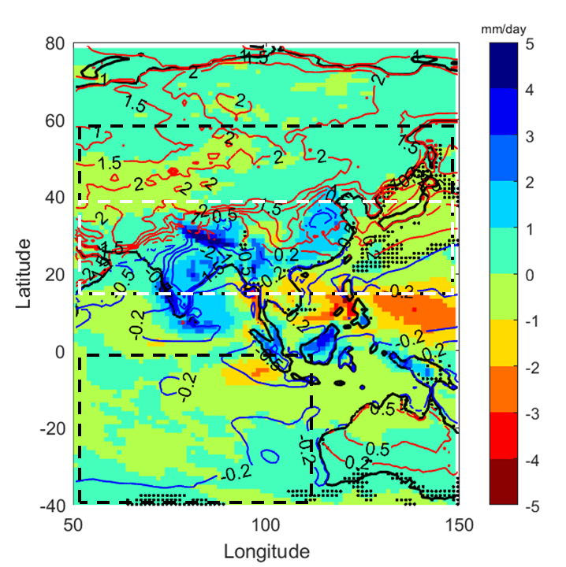
Figure 1. Seasonal mean of the rainfall (shaded color, in mm/day) and surface temperature (contour, in K) during boreal summer for the mid-Holocene minus pre-Industrial simulations by the MRI-CGCM3. Contours in red and blue represent positive and negative changes in temperature respectively. Dotted areas are not significant at 95% confidence level for the rainfall change. Black dashed rectangles are areas to calculate area-averaged surface temperature, while white dashed rectangle is the area used to calculate area-averaged rainfall.

Table 1. General description of the nine GCMs involved in this study. All models are part ot the PMIP3 which their simulation output are freely accessible in cera-www.dkrz.de. (https://wiki.lsce.ipsl.fr/pmip3/doku.php/pmip3:database:status).
Model name | Country | Number of  horizontal grid and  vertical layers | Length of simulation  per-scenario (Year) |  | Cite
Model name | Country | Number of  horizontal grid and  vertical layers | pre-Industrial | mid-Holocene | Cite
BCC-CSM1 | China | 128 x 64 x L21 | 1500 | 100 | (Wu & Xin, 2015)
CCSM4 | USA | 288 x 192 x L26 | 1503 | 903 | (Otto-Bliesner, 2014)
CESS FGOALS-S2 | UK | 192 x 145 x L38 | 30 | 30 | (LASG 2015)
CSIRO MK-3-6-0 | Australia | 64 x 56 x L1 | 1353 | 153 | (Jeffrey et al., 2016)
IPSL-CM5A-LR | Prancis | 96 x 95 x L39 | 2703 | 1203 | (Braconnot et al., 2016)
MIROC ESM | Japan | 36 x 43 x L40 | 277 | 243 | (JAMSTEC et al., 2015)
MPI ESM-P | Japan | 196 x 98 x L47 | 603 | 273 | (Jungclaus et al., 2012)
MRI-CGCM3 | Japan | 364 x 160 x L48 | 1203 | 273 | (Yukimoto et al., 2015)
NASA GISS-E2-R | USA | 40 x 60 x L40 | 63 | 63 | (NASA 2014)

Table 2 Mean of the investigated physical quantities during boreal summer for the mid-Holocene minus pre-Industrial of the nine GCMs. See equation 1 to 7 for the detail calculations. All means are significant at 95% confidence level.
No | Global Model Data | ∆T_{as} (K) | ∆T_{oc} (K) | ∂∆T (K) | ∆P_{as} (mm/day) | ∆IM_{a} (m/s)
1 | BCC-CSM1 | 1.03 | -0.42 | 1.45 | 0.27 | 0.61
2 | CCSM4 | 0.70 | -0.32 | 1.02 | 0.25 | 0.57
3 | CESS FGOALS G2 | 0.84 | -0.63 | 1.47 | 0.19 | 0.73
4 | CSIRO MK3-6-0 | 1.09 | -0.22 | 1.32 | 0.68 | 0.79
5 | IPSL CM5A | 0.99 | -0.34 | 1.33 | 0.43 | 1.40
6 | MIROC ESM | 0.72 | -0.60 | 1.32 | 0.47 | 1.40
7 | MPI ESM P | 0.77 | -0.37 | 1.14 | 0.56 | 1.87
8 | MRI CGCM3 | 1.08 | -0.32 | 1.40 | 0.37 | 0.79
9 | NASA GISS E2 R | 0.57 | -0.26 | 0.83 | 0.41 | 0.95

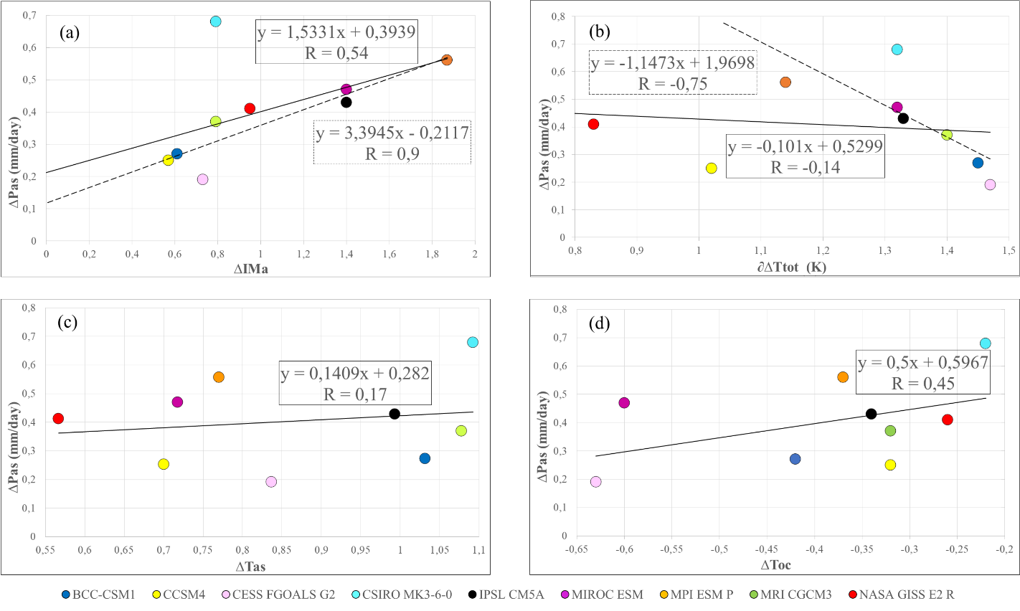
Figure 2 Link between seasonal mean of Asian summer rainfall (∆P_{as}) with (a) Monsoon index (∆IM_{a}), (b) Continent-ocean thermal gradient (∂∆T), (c) Asian surface temperature (∆T_{as}), and (d) Indian Ocean SST (∆T_{oc}) for the mid-Holocene minus pre-Industrial as simulated by the nine GCMs from PMIP3. Solid lines are based on the linear regression of all GCMs, while dashed lines are regressed without CSIRO Mk3-6-0 (a) and CCSM4 and GISS E2-R (b). Text boxes contain correlation scores and linear equations of the nearest regression line.

